|  |  |  |  |
| --- | --- | --- | --- |
| **INDEX** | | | |
| **S.No.** | **Contents** | **Page No.** | **Date** |
| 1 | UML Introduction | 1 | 06-07-2015 |
| 2.1 | UML Diagrams for ATM System | 3 | 13-07-2015 |
| 2.1a | Use-case Diagram | 3 | 13-07-2015 |
| 2.1b | Class Diagram | 3 | 13-07-2015 |
| 2.1c | Sequence Diagram | 4 | 20-07-2015 |
| 2.1d | Collaboration Diagram | 4 | 20-07-2015 |
| 2.1e | Activity Diagram | 5 | 27-07-2015 |
| 2.1f | Statechart Diagram | 5 | 27-07-2015 |
| 2.1g | Component Diagram | 6 | 03-08-2015 |
| 2.1h | Deployment Diagram | 7 | 27-07-2015 |
| 2.2 | UML Diagrams for Library Management System | 8 | 13-07-2015 |
| 2.2a | Use-case Diagram | 8 | 13-07-2015 |
| 2.2b | Class Diagram | 9 | 13-07-2015 |
| 2.2c | Sequence Diagram | 10 | 20-07-2015 |
| 2.2d | Collaboration Diagram | 10 | 20-07-2015 |
| 2.2e | Activity Diagram | 11 | 27-07-2015 |
| 2.2f | Statechart Diagram | 11 | 27-07-2015 |
| 2.2g | Component Diagram | 12 | 03-08-2015 |
| 2.2h | Deployment Diagram | 12 | 27-07-2015 |
| 2.3 | UML Diagrams for Student Enrolment System | 13 | 13-07-2015 |
| 2.3a | Use-case Diagram | 13 | 13-07-2015 |
| 2.3b | Class Diagram | 14 | 13-07-2015 |
| 2.3c | Sequence Diagram | 15 | 20-07-2015 |
| 2.3d | Collaboration Diagram | 15 | 20-07-2015 |
| 2.3e | Activity Diagram | 16 | 27-07-2015 |
| 2.3f | Statechart Diagram | 16 | 27-07-2015 |
| 2.3g | Component Diagram | 17 | 03-08-2015 |
| 2.3h | Deployment Diagram | 17 | 27-07-2015 |
| 2.4 | UML Diagrams for Online Reservation System | 18 | 13-07-2015 |
| 2.4a | Use-case Diagram | 18 | 13-07-2015 |
| 2.4b | Class Diagram | 19 | 13-07-2015 |
| 2.4c | Sequence Diagram | 19 | 20-07-2015 |
| 2.4d | Collaboration Diagram | 20 | 20-07-2015 |
| 2.4e | Activity Diagram | 20 | 27-07-2015 |
| 2.4f | Statechart Diagram | 21 | 27-07-2015 |
| 2.4g | Component Diagram | 21 | 03-08-2015 |
| 2.4h | Deployment Diagram | 22 | 27-07-2015 |
| 2.5 | UML Diagrams for Stock Maintenance System | 23 | 13-07-2015 |
| 2.5a | Use-case Diagram | 23 | 13-07-2015 |
| 2.5b | Class Diagram | 24 | 13-07-2015 |
| 2.5c | Sequence Diagram | 25 | 20-07-2015 |
| 2.5d | Collaboration Diagram | 26 | 20-07-2015 |
| 2.5e | Activity Diagram | 26 | 27-07-2015 |
| 2.5f | Statechart Diagram | 27 | 27-07-2015 |
| 2.5g | Component Diagram | 27 | 03-08-2015 |
| 2.5h | Deployment Diagram | 27 | 27-07-2015 |
| 2.6 | UML Diagrams for Payroll System | 28 | 13-07-2015 |
| 2.6a | Use-case Diagram | 28 | 13-07-2015 |
| 2.6b | Class Diagram | 29 | 13-07-2015 |
| 2.6c | Sequence Diagram | 30 | 20-07-2015 |
| 2.6d | Collaboration Diagram | 30 | 20-07-2015 |
| 2.6e | Activity Diagram | 31 | 27-07-2015 |
| 2.6f | Statechart Diagram | 31 | 27-07-2015 |
| 2.6g | Component Diagram | 32 | 03-08-2015 |
| 2.6h | Deployment Diagram | 32 | 27-07-2015 |
| 3 | WinRunner-case Tool | 33 | 10-08-2015 |
| TASK-1 | Recording in Context Sensitive mode and Analog mode | 34 | 24-08-2015 |
| TASK-2 | GUI checkpoint | 41 | 07-09-2015 |
| a) | For Single Property | 41 | 07-09-2015 |
| b) | For Single Object/Window | 44 | 07-09-2015 |
| c) | For Multiple Objects | 47 | 14-09-2015 |
| TASK-3 | Bitmap Checkpoint | 51 | 28-09-2015 |
| a) | For Object/Window | 51 | 28-09-2015 |
| b) | For Screen area | 54 | 28-09-2015 |
| TASK-4 | Database Checkpoint | 57 | 05-10-2015 |
| a) | For Default check | 57 | 05-10-2015 |
| b) | For Custom check | 66 | 05-10-2015 |
| c) | For Runtime record check | 73 | 07-10-2015 |
| TASK-5 | Data Driven Test | 79 | 26-10-2015 |
| a) | For Dynamic test data submission | 79 | 26-10-2015 |
| b) | Through Flat files | 85 | 26-10-2015 |
| c) | Through Excel Sheets | 91 | 26-10-2015 |
| TASK-6 | Batch Testing | 97 | 07-10-2015 |
| a) | Without parameter passing | 97 | 07-10-2015 |
| b) | With parameter passing | 100 | 28-10-2015 |
| TASK-7 | Function Generator | 103 | 28-10-2015 |
| TASK-8 | Executing a prepared query | 106 | 28-10-2015 |
| TASK-9 | Synchronization | 108 | 07-10-2015 |
| a) | For Object/Window property | 108 | 07-10-2015 |
| b) | For Object/Window bitmap | 112 | 07-10-2015 |
| c) | For Screen area bitmap | 115 | 07-10-2015 |
| TASK-10 | Test Cases | 118 | 07-10-2015 |
| a) | Test case for Calculator in windows application | 118 | 07-10-2015 |
| b) | Test case for Flight Reservation System | 122 | 07-10-2015 |

|  |
| --- |
| **CASE TOOLS & OOAD LAB** |
| **SOFTWARE TESTING LAB** |

**RATIONAL ROSE-CASE TOOL**

1. **UML INTRODUCTION**

The Unified Modeling Language(UML) is a general-purpose, developmental, [modeling language](https://en.wikipedia.org/wiki/Modeling_language)in the field of [software engineering](https://en.wikipedia.org/wiki/Software_engineering), that is intended to provide a standard way to visualize the design of a system.

UML was originally motivated by the desire to standardize the disparate notational systems and approaches to software design developed by [Grady Booch](https://en.wikipedia.org/wiki/Grady_Booch), [Ivar Jacobson](https://en.wikipedia.org/wiki/Ivar_Jacobson) and [James Rumbaugh](https://en.wikipedia.org/wiki/James_Rumbaugh) at [Rational Software](https://en.wikipedia.org/wiki/Rational_Software) in 1994–95, with further development led by them through 1996.

In 1997 UML was adopted as a standard by the [Object Management Group](https://en.wikipedia.org/wiki/Object_Management_Group) (OMG), and has been managed by this organization ever since. In 2005 the Unified Modeling Language was also published by the [International Organization for Standardization](https://en.wikipedia.org/wiki/International_Organization_for_Standardization) (ISO) as an approved ISO standard. Since then it has been periodically revised to cover the latest revision of UML.

UML specification defines two major kinds of UML diagram: [structure diagrams](http://www.uml-diagrams.org/uml-25-diagrams.html#structure-diagram) and [behavior diagrams](http://www.uml-diagrams.org/uml-25-diagrams.html#behavior-diagram).

[Structure diagrams](http://www.uml-diagrams.org/uml-25-diagrams.html#structure-diagram) show the **static structure** of the system and its parts on different abstraction and implementation **levels** and how they are related to each other. The elements in a structure diagram represent the meaningful concepts of a system, and may include abstract, real world and implementation concepts.

[Behavior diagrams](http://www.uml-diagrams.org/uml-25-diagrams.html#behavior-diagram) show the **dynamic behavior** of the objects in a system, which can be described as a series of changes to the system over **time**.

Structural UML diagrams

* Class diagram: [Class diagrams](http://www.smartdraw.com/class-diagram/) are the backbone of almost every object-oriented method, including UML. They describe the static structure of a system.
* Package diagram: Package diagrams are a subset of class diagrams, but developers sometimes treat them as a separate technique. Package diagrams organize elements of a system into related groups to minimize dependencies between packages.
* Object diagram: Object diagrams describe the static structure of a system at a particular time. They can be used to test class diagrams for accuracy.
* Component diagram: [Component diagrams](http://www.smartdraw.com/component-diagram/) describe the organization of physical software components, including source code, run-time (binary) code, and executables.
* Composite structure diagram: Composite structure diagrams show the internal part of a class.
* Deployment diagram: Deployment diagrams depict the physical resources in a system, including nodes, components, and connections.

Behavioral UML diagrams

* Activity diagram: [Activity diagrams](http://www.smartdraw.com/activity-diagram/) illustrate the dynamic nature of a system by modeling the flow of control from activity to activity. An activity represents an operation on some class in the system that results in a change in the state of the system. Typically, activity diagrams are used to model workflow or business processes and internal operation.
* Sequence diagram: [Sequence diagrams](http://www.smartdraw.com/sequence-diagram/) describe interactions among classes in terms of an exchange of messages over time.
* Use case diagram: [Use case diagrams](http://www.smartdraw.com/use-case-diagram/) model the functionality of a system using actors and use cases.
* State diagram: [Statechart diagrams](http://www.smartdraw.com/state-diagram/), now known as state machine diagrams and state diagrams describe the dynamic behavior of a system in response to external stimuli. State diagrams are especially useful in modeling reactive objects whose states are triggered by specific events.
* Communication diagram: Communication diagrams model the interactions between objects in sequence. They describe both the static structure and the dynamic behavior of a system. In many ways, a communication diagram is a simplified version of a collaboration diagram introduced in UML 2.0
* Interaction overview diagram: Interaction overview diagrams are a combination of activity and sequence diagrams. They model a sequence of actions and let you deconstruct more complex interactions into manageable occurrences. You should use the same notation on interaction overview diagrams that you would see on an activity diagram.
* Timing diagram: A timing diagram is a type of behavioral or interaction UML diagram that focuses on processes that take place during a specific period of time. They're a special instance of a sequence diagram, except time is shown to increase from left to right instead of top down.
  1. **UML DIAGRAMS FOR ATM SYSTEM**

1. **USE-CASE DIAGRAM**

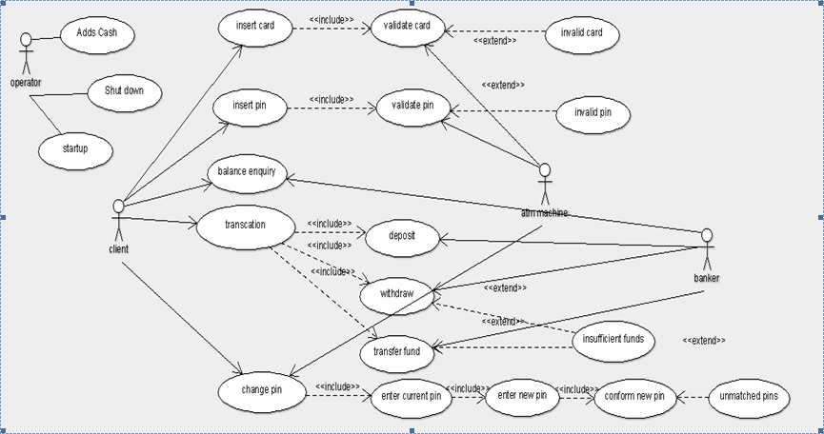

1. **CLASS DIAGRAM**

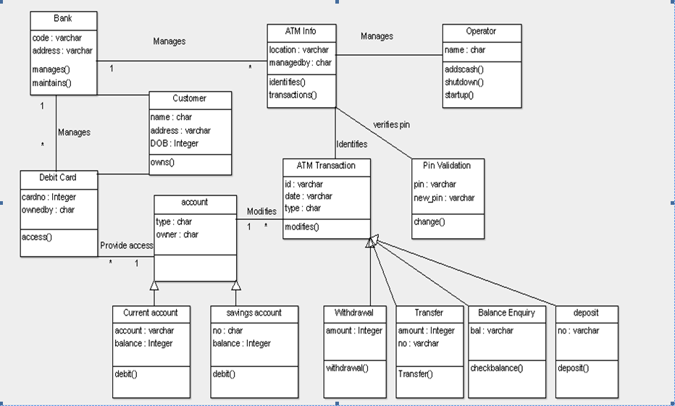

**SEQUENCE DIAGRAM**

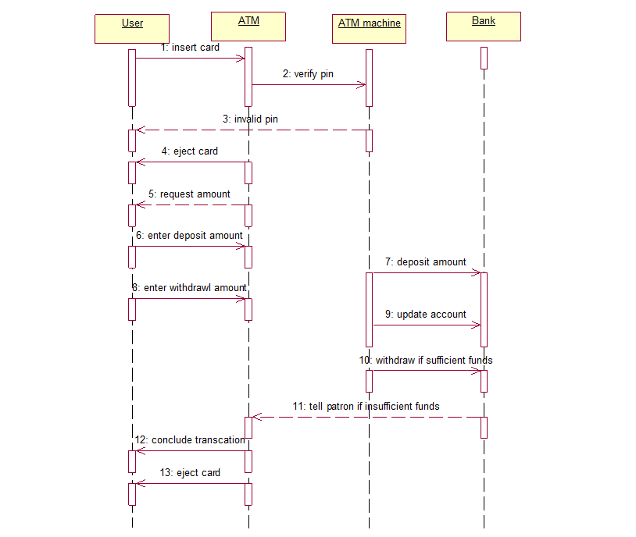

1. **COLLABORATION DIAGRAM**

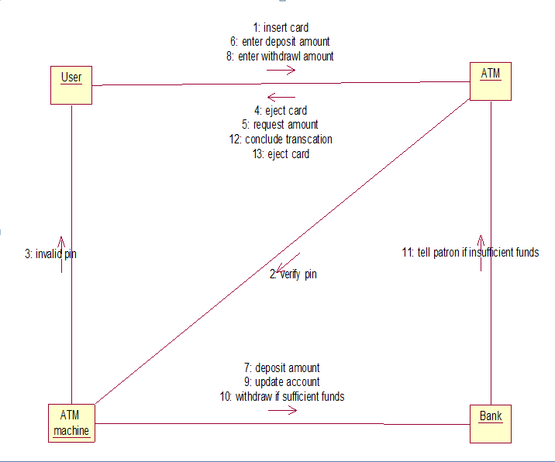

1. **ACTIVITY DIAGRAM**

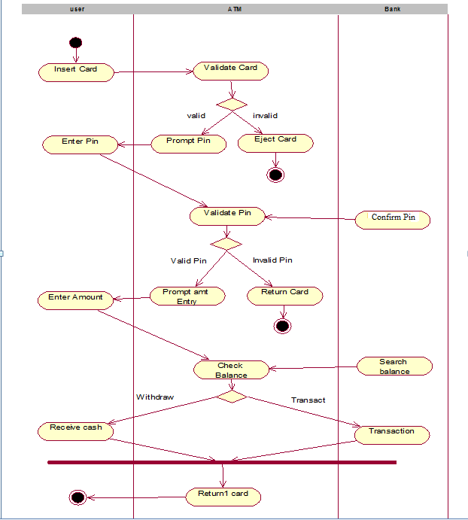

1. **STATECHART DIAGRAM**

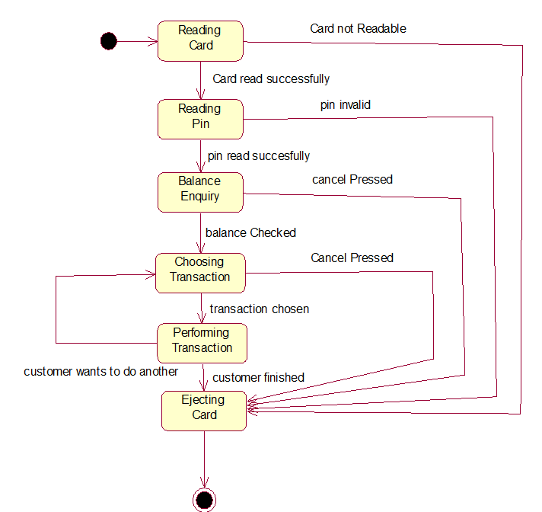

1. **COMPONENT DIAGRAM**

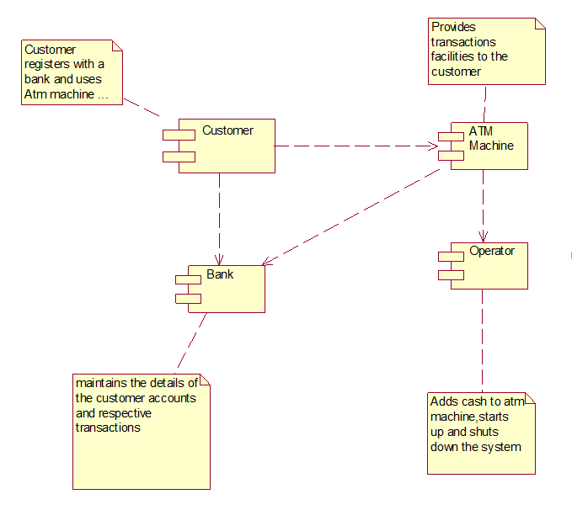

1. **DEPLOYMENT DIAGRAM**

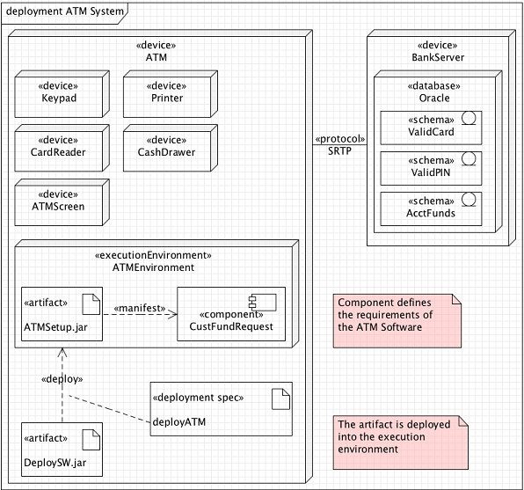

* 1. **UML DIAGRAMS FOR LIBRARY MANAGEMENT SYSTEM**

1. **USE-CASE DIAGRAM**

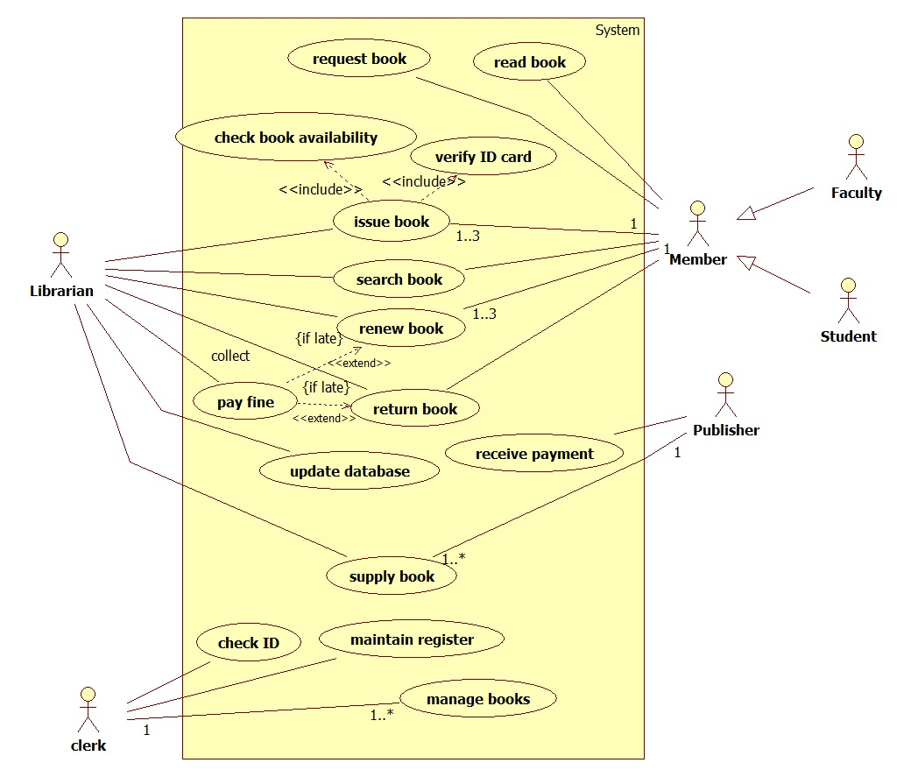

1. **CLASS DIAGRAM**

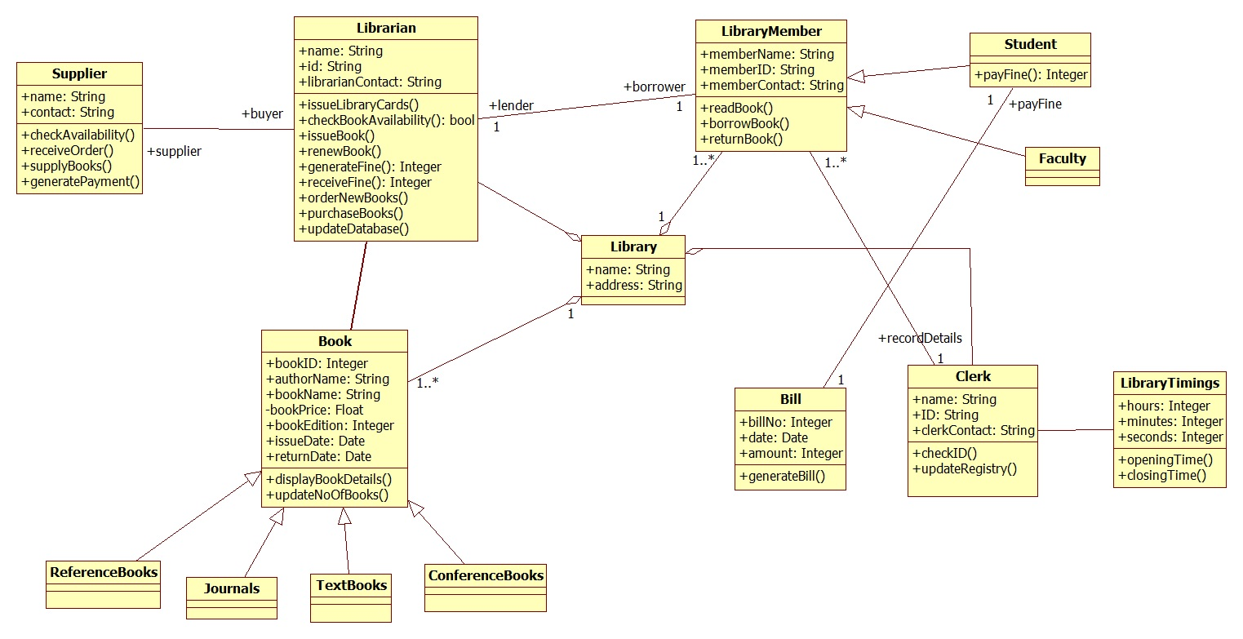

1. **SEQUENCE DIAGRAM**

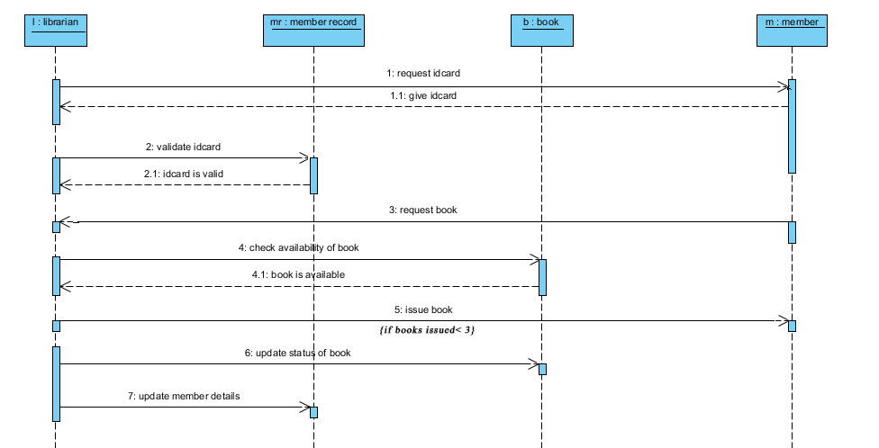

1. **COLLABORATION DIAGRAM**

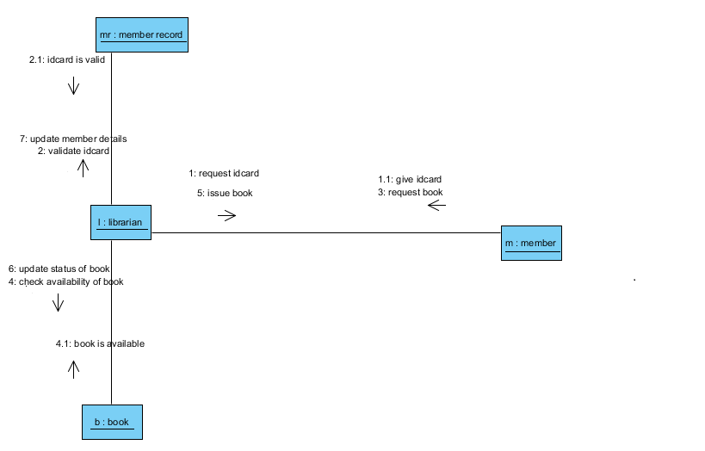

1. **ACTIVITY DIAGRAM**



1. **STATECHART DIAGRAM**



1. **COMPONENT DIAGRAM**



1. **DEPLOYMENT DIAGRAM**



* 1. **UML DIAGRAMS FOR STUDENT ENROLMENT SYSTEM**

1. **USE-CASE DIAGRAM**

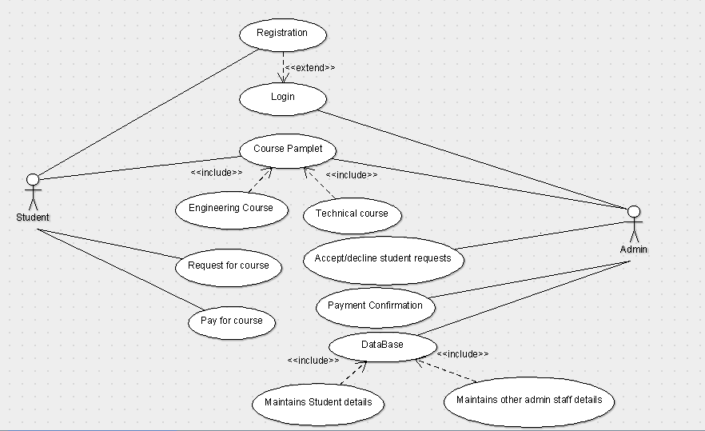

1. **CLASS DIAGRAM**

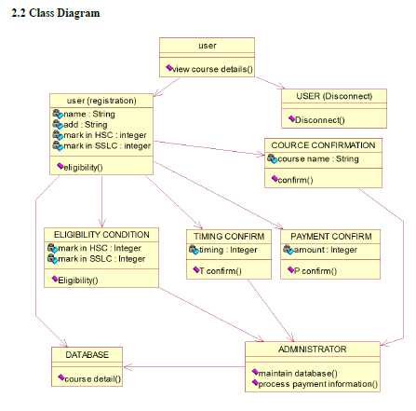

1. **SEQUENCE DIAGRAM**

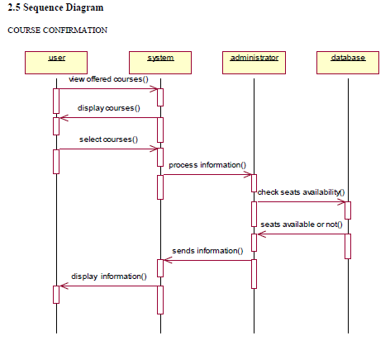

1. **COLLABORATION DIAGRAM**

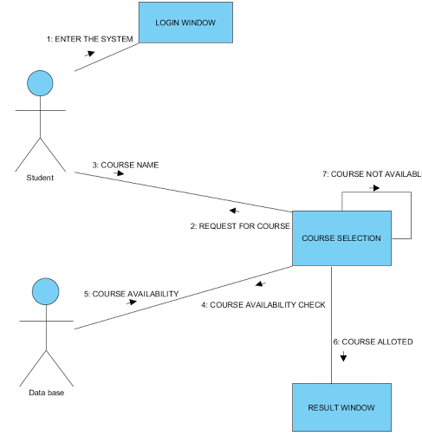

1. **ACTIVITY DIAGRAM**

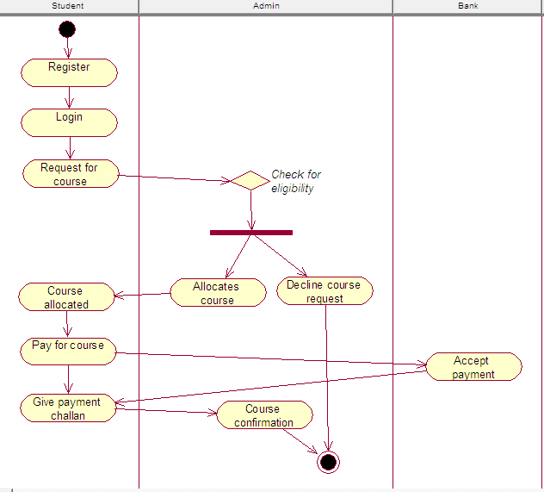

1. **STATECHART DIAGRAM**

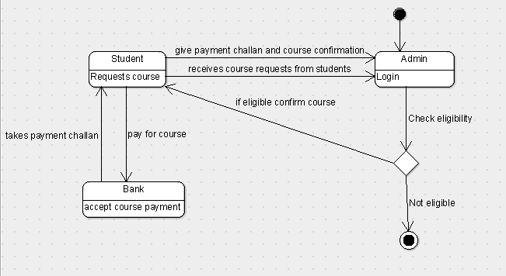

1. **COMPONENT DIAGRAM**

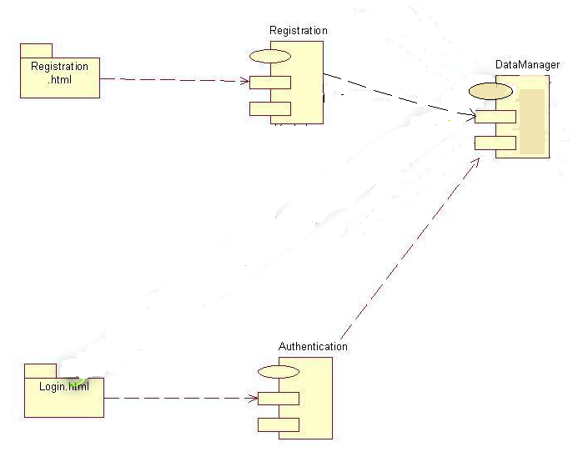

1. **DEPLOYMENT DIAGRAM**

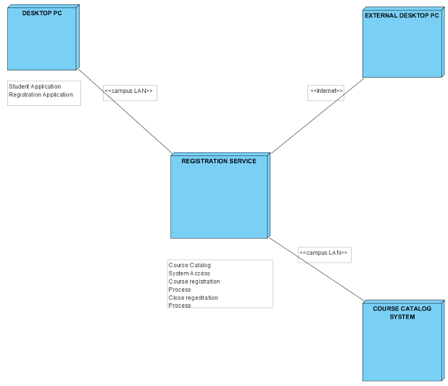

* 1. **UML DIAGRAMS FOR ONLINE RESERVATION SYSTEM**

1. **USE-CASE DIAGRAM**

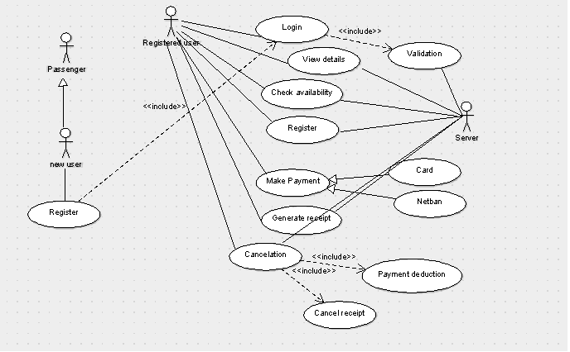

1. **CLASS DIAGRAM**

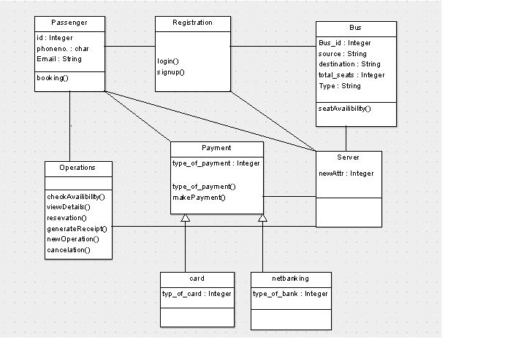

1. **SEQUENCE DIAGRAM**

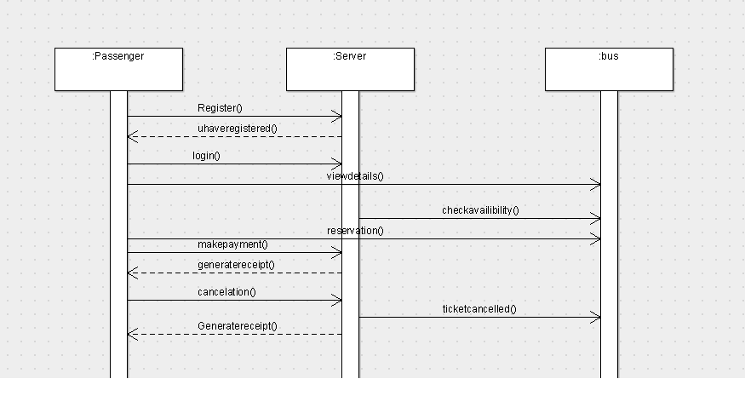

1. **COLLABORATION DIAGRAM**

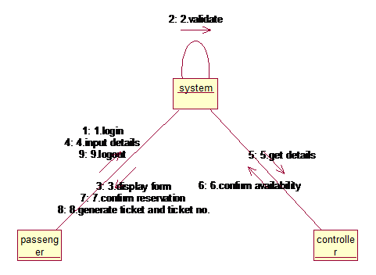

1. **ACTIVITY DIAGRAM**

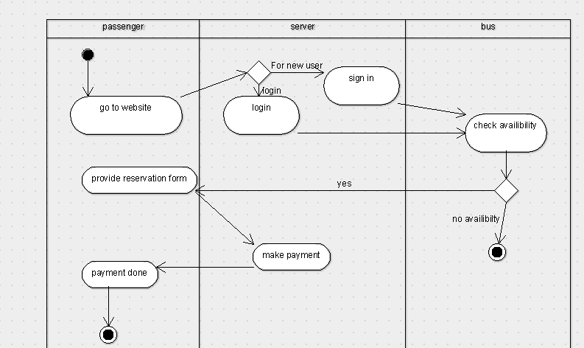

1. **STATECHART DIAGRAM**

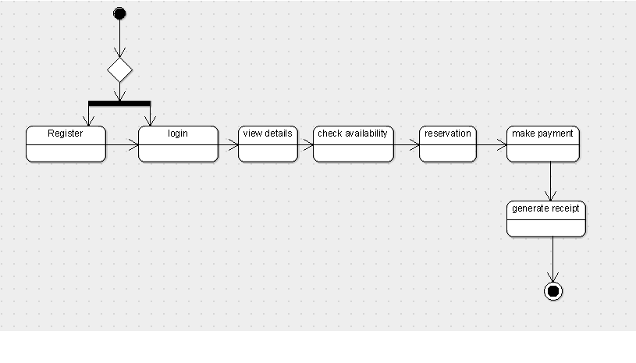

1. **COMPONENT DIAGRAM**

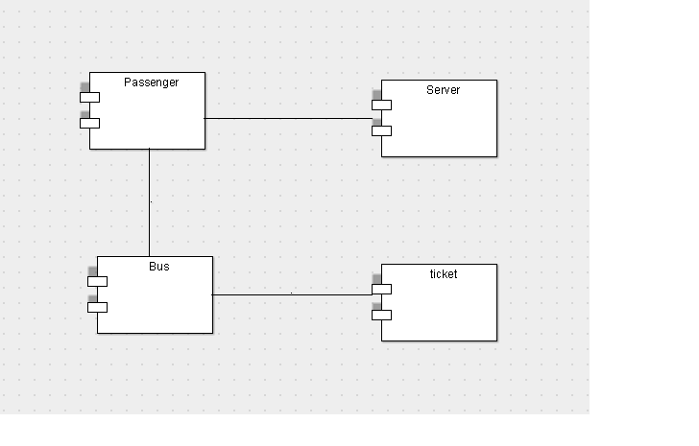

1. **DEPLOYMENT DIAGRAM**

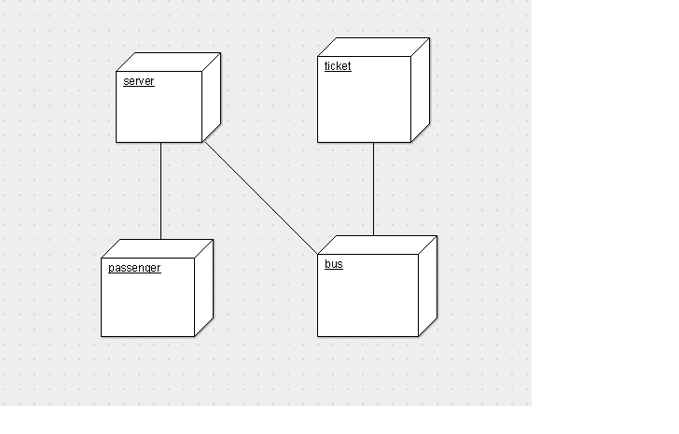

* 1. **UML DIAGRAMS FOR STOCK MAINTENANCE SYSTEM**

1. **USE-CASE DIAGRAM**

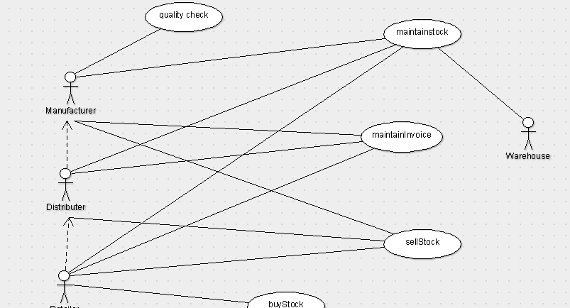

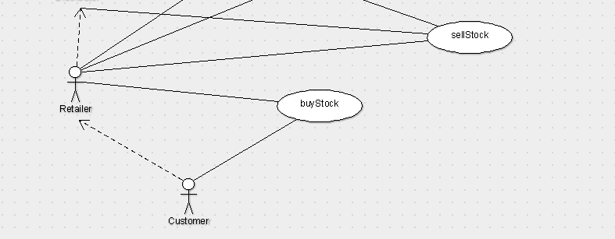

1. **CLASS DIAGRAM**

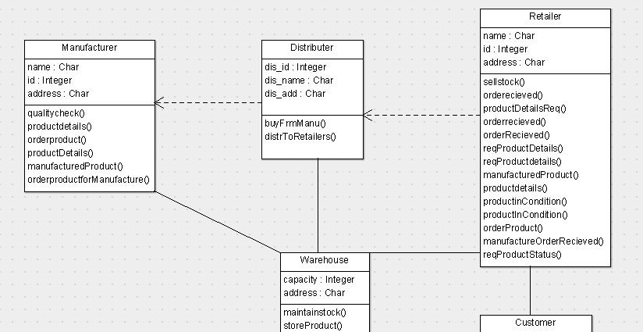

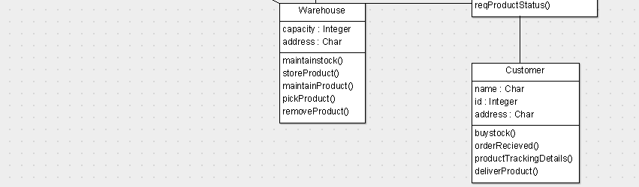

1. **SEQUENCE DIAGRAM**

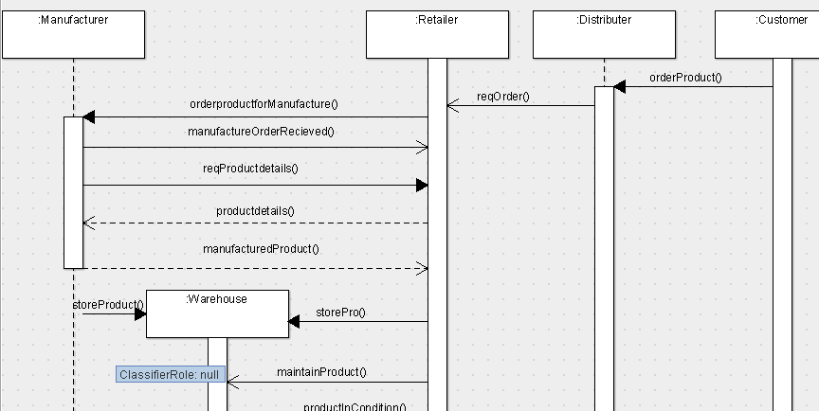

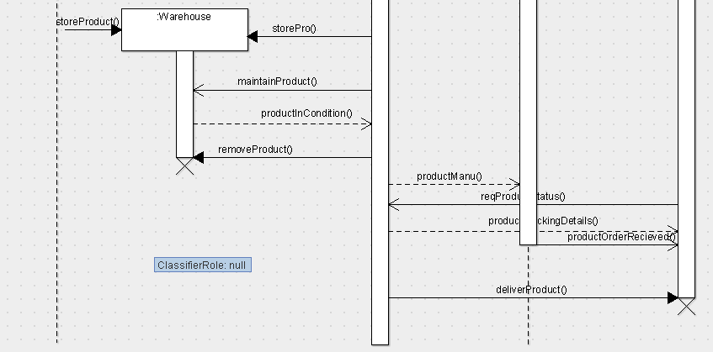

1. **COLLABORATION**



1. **ACTIVITY DIAGRAM**

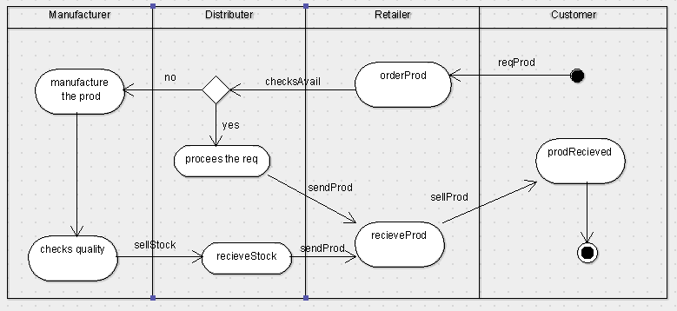

1. **STATECHART DIAGRAM**

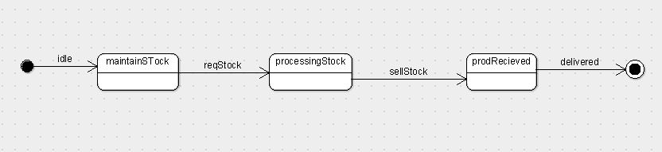

1. **COMPONENT DIAGRAM**

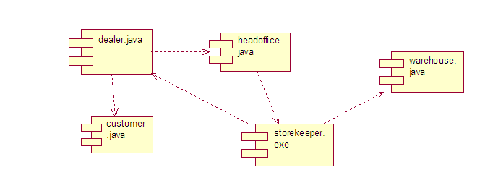

1. **DEPLOYMENT DIAGRAM**

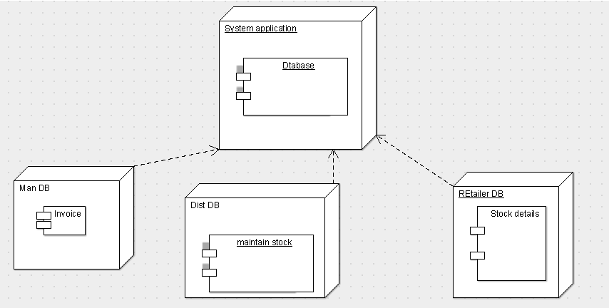

* 1. **UML DIAGRAMS FOR PAYROLL SYSTEM**

1. **USE-CASE DIAGRAM**

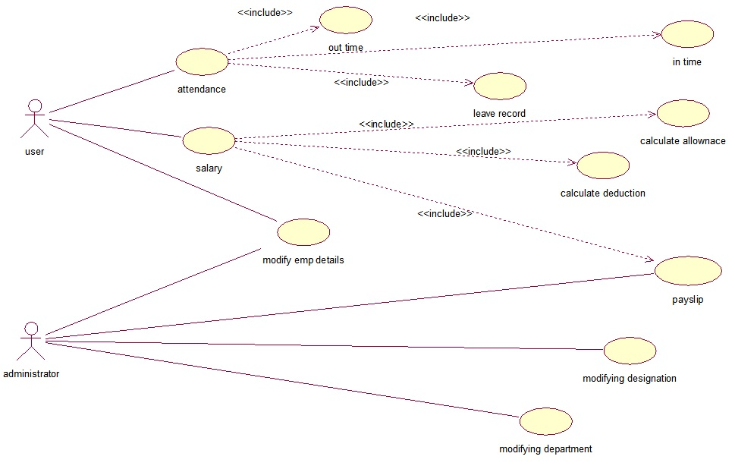

1. **CLASS DIAGRAM**

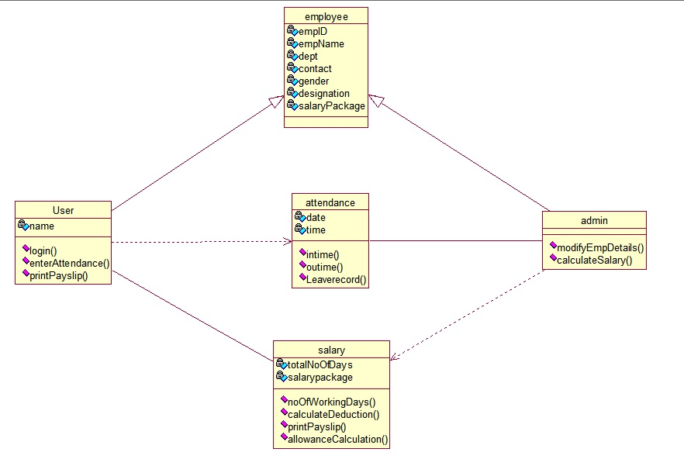

1. **SEQUENCE DIAGRAM**

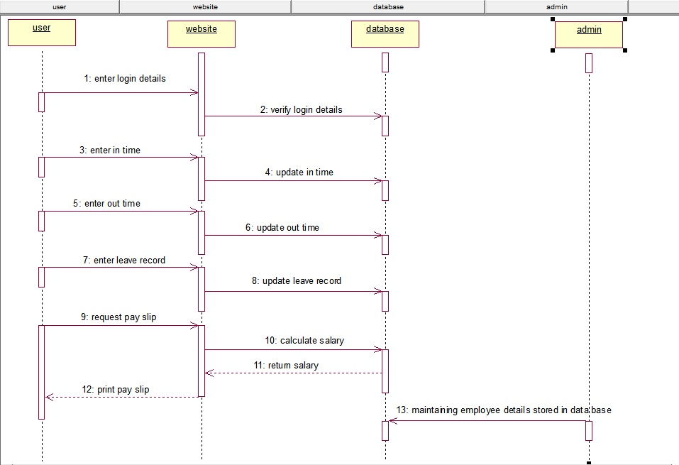

1. **COLLABORATION DIAGRAM**

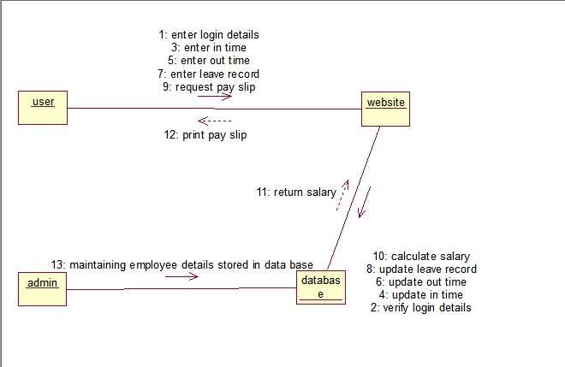

1. **ACTIVITY DIAGRAM**

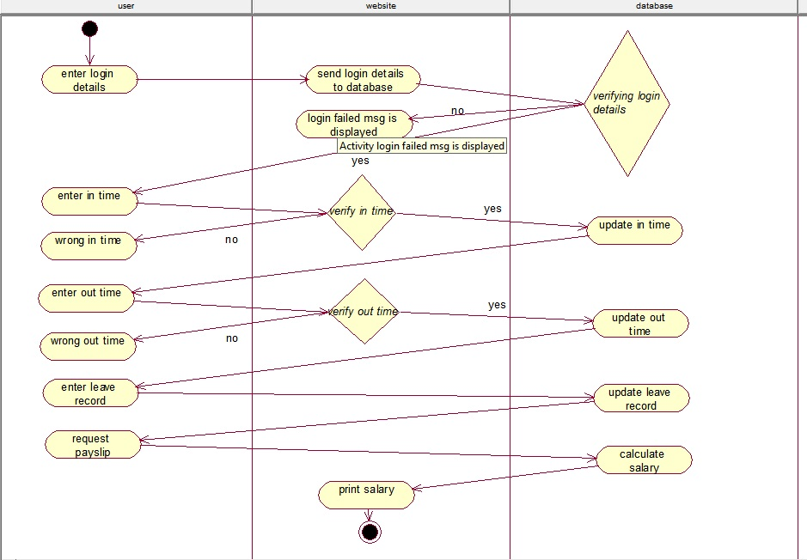

1. **STATECHART DIAGRAM**

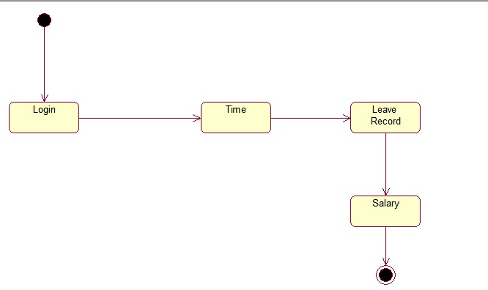

1. **COMPONENT DIAGRAM**

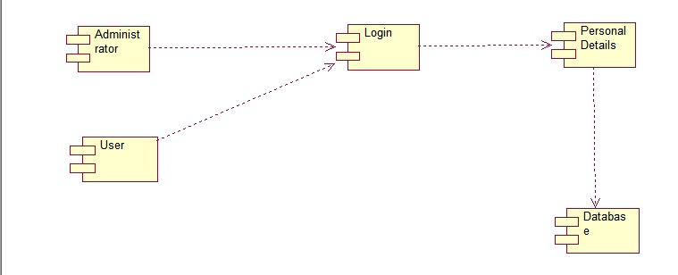

1. **DEPLOYMENT DIAGRAM**

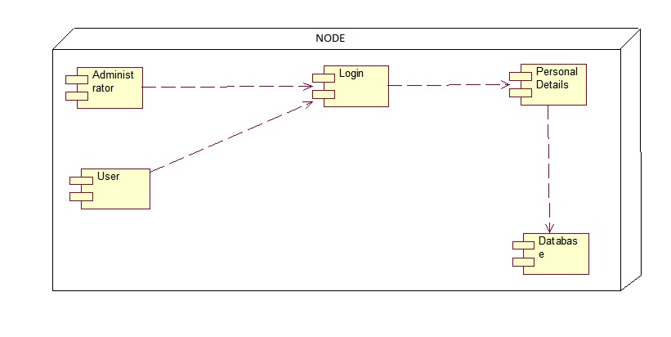

1. **WINRUNNER-CASE TOOLS**

**INTRODUCTION TO WINRUNNER**

Winrunner helps you automate the testing process, from test development to execution. You create adaptable and reusable test scripts that challenge the functionality of your application. Prior to a software release, you can run these tests in a single overnight run- enabling you to detect and ensure superior software quality.

Main Features of **Win Runner** are

**Product:** Mercury Interactive or Hewlett Packard (HP)

**Purpose:** Functionality and Regression Testing Tool

**Kinds of application:** All kinds of application (web Based and Window Based).

**Language**: Test Script Language

**Technology:** Object oriented Technology

**Object Oriented Technology:**

* It will recognise each and every control/field present in the application as an object.
* Each and every object present in the application has its own properties. The object and their properties are getting stored in the **GUI Map File**. Map File is the heart of the winrunner.

User can create tests using recording or programming or by both. While recording, each operation performed by the user generates a statement in the Test Script Language (TSL). These statements are displayed as a test script in a test window. User can then enhance the recorded test script, either by typing in additional TSL functions and programming elements or by using WinRunner’s visual programming tool, the Function Generator, or using the Function Viewer. 

**TASK-1:** RECORDING IN CONTEXT SENSITIVE MODE AND ANALOG MODE

**CONTEXT SENSITIVE:**

WinRunner records the operations you perform on the GUI objects in your application, and inserts the appropriate TSL statements into your test script.

Context Sensitive mode records the operations user performed on the application by identifying Graphical User Interface (GUI) objects. Context Sensitivity test scripts can be reused in the future version of the application because WinRunner writes a unique description of each selected object to a GUI map file. The GUI map files are maintained separately from test scripts and the same GUI map file (or files) can be used for multiple tests.

STEP-1: Start->Programs->WinRunner->Create->Record-Context Sensitive

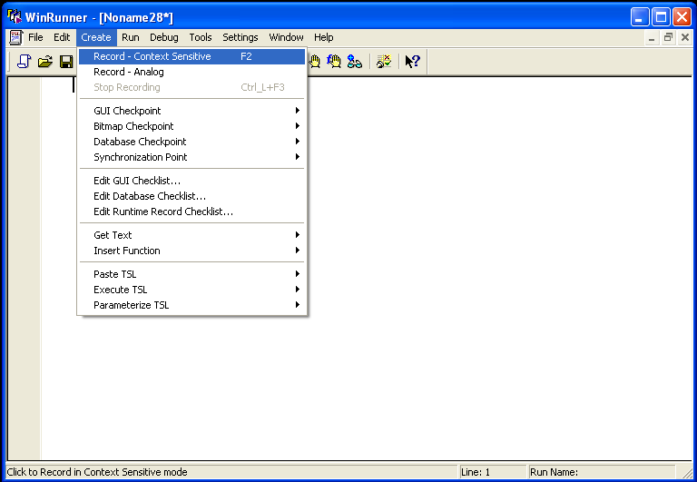

STEP-2:Open Flight Reservation application, a **Login** window opens.

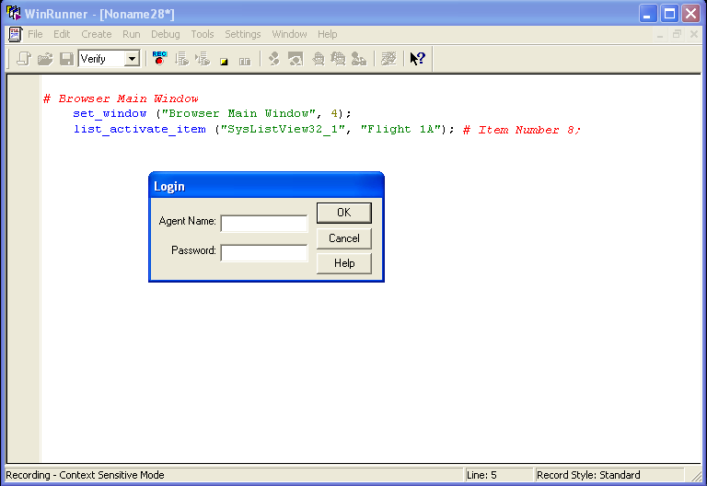

STEP-3: Fill in your desired **Agent Name** and “mercury” as **Password.**

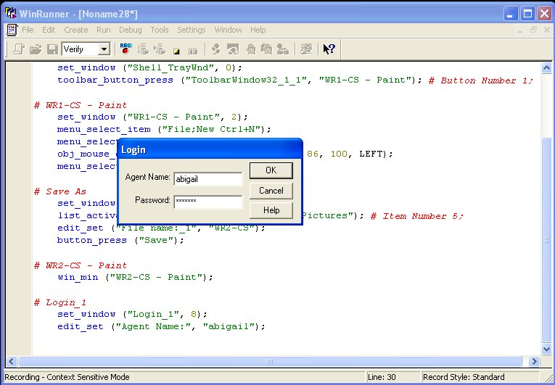

STEP-4:Fill in the details for flight reservation and press “Insert Order”.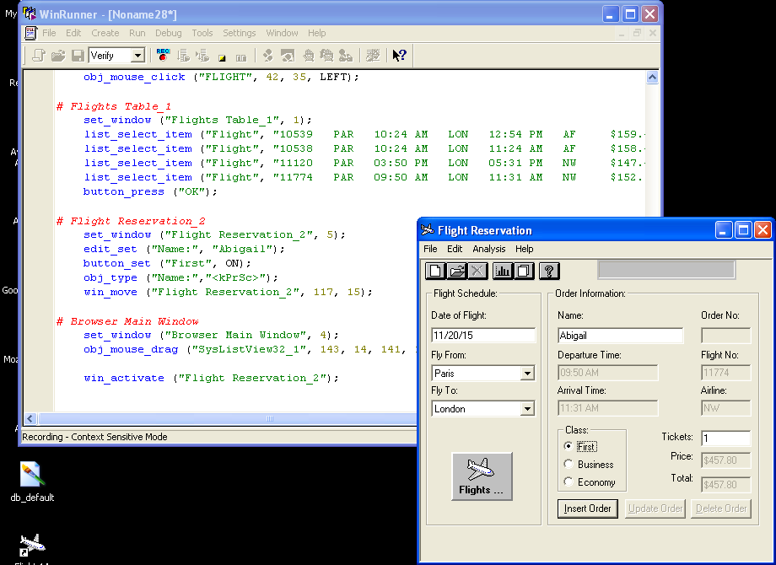

STEP-5:Run from Top 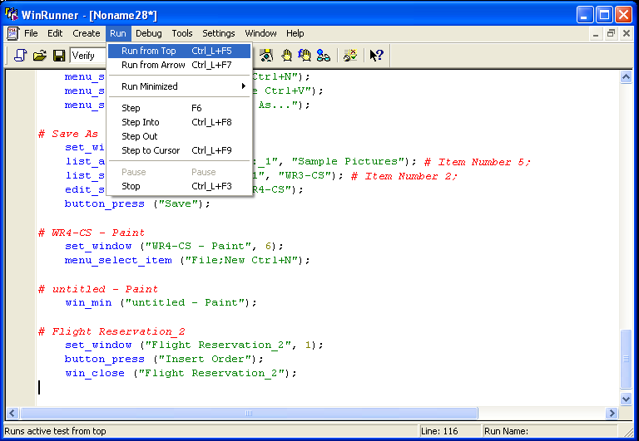

STEP-6: View the test results in the **WinRunner Test Results** window.

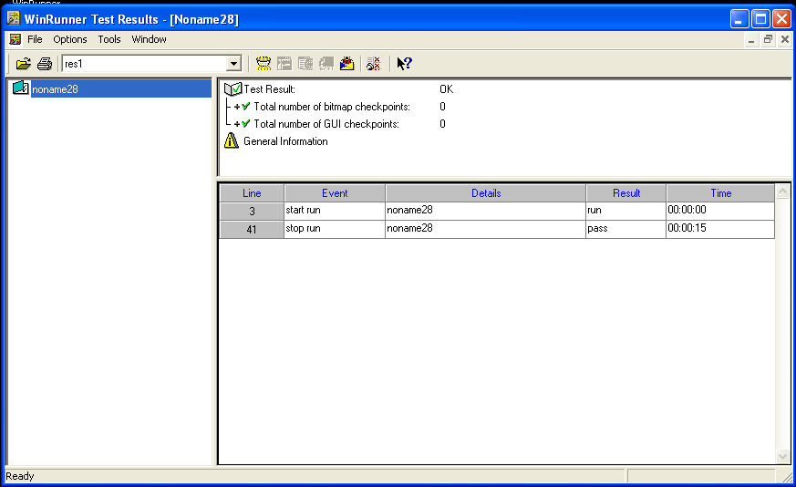

**ANALOG:**

  WinRunner records the operations you perform on your application, including keyboard input, mouse clicks, and the exact coordinates of the mouse pointer as it travels across your screen.

Analog mode records mouse clicks, keyboard input, and the exact x-and y-coordinates traveled by the mouse. When the test is run, WinRunner retraces the mouse tracks. Use Analog mode when exact mouse coordinates are important to the test, such as when testing a drawing application.

STEP-1: Start->Programs->WinRunner->Create->Record-Analog

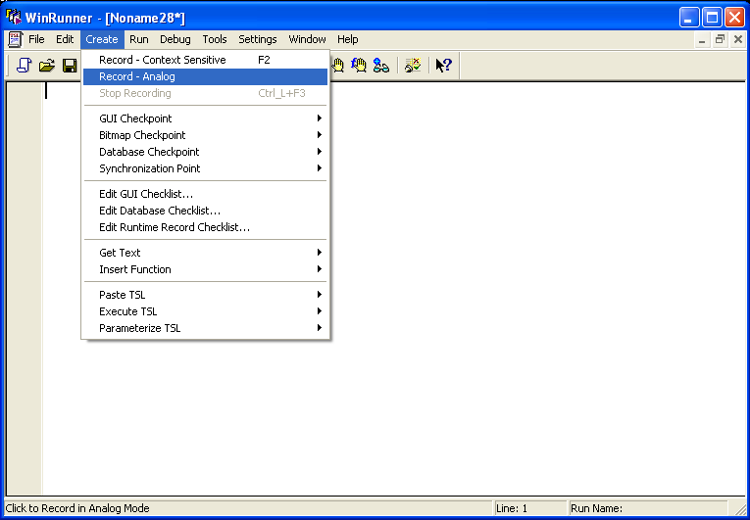

STEP-2:Open Flight Reservation application, a **Login** window opens.

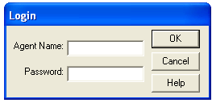

STEP-3: Fill in your desired **Agent Name** and “mercury” as **Password.**

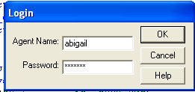

STEP-4:Fill in the details for flight reservation and press “Insert Order”.

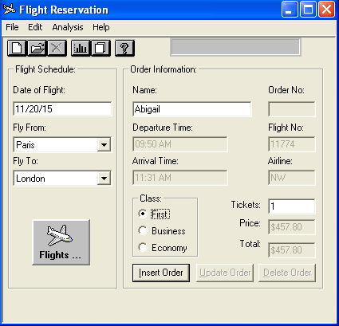

STEP-5:Run from Top



STEP-6: View the test results in the **WinRunner Test Results** window.

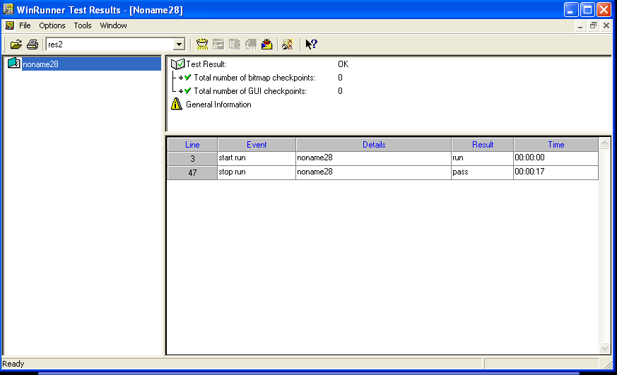

**TASK-2:**

1. GUI CHECKPOINT FOR SINGLE PROPERTY.
2. GUI CHECKPOINT FOR SINGLE OBJECT/WINDOW.
3. GUI CHECKPOINT FOR MULTIPLE OBJECTS.

**GUI Checkpoint:** It is used to compare the expected Result versus Actual Result.

1. **GUI checkpoint for single property:** This checkpoint is used to check the state or properties of a single object or window in an application. If a user single-click on a GUI object, the default checks for that object are included in the GUI checkpoint. If the user double-clicks on a GUI object, after WinRunner capturing GUI data, the Check GUI dialog box opens. User can choose which checks to include for that particular object. When using a GUI Checkpoint command, WinRunner inserts a checkpoint statement into the test script.The property check verifies the value of a single property of a GUI object.

STEP-1: Set Context sensitive mode.

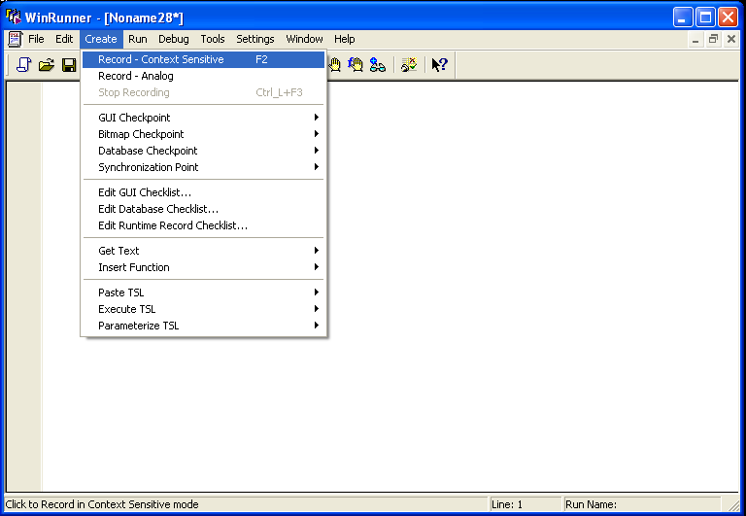

STEP-2: Open Flight Application and Insert an order. Don’t close the Flight Reservation window.

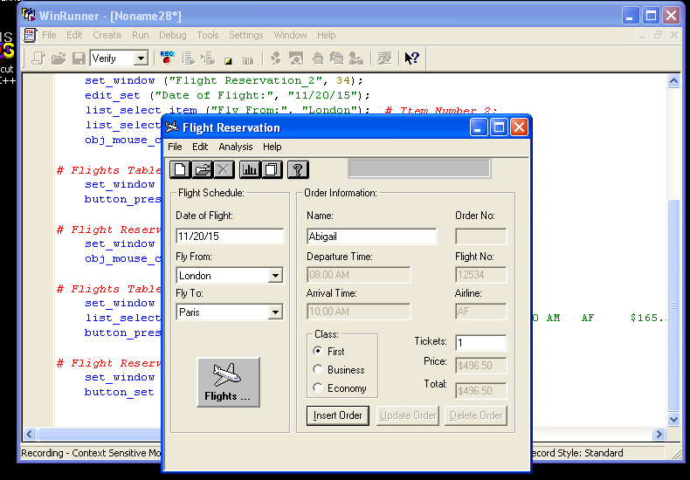

STEP-3: In WinRunner, goto **Create->GUI Checkpoint->For Single Property**. Select any property in the Flight Reservation window and “Right click” on mouse.

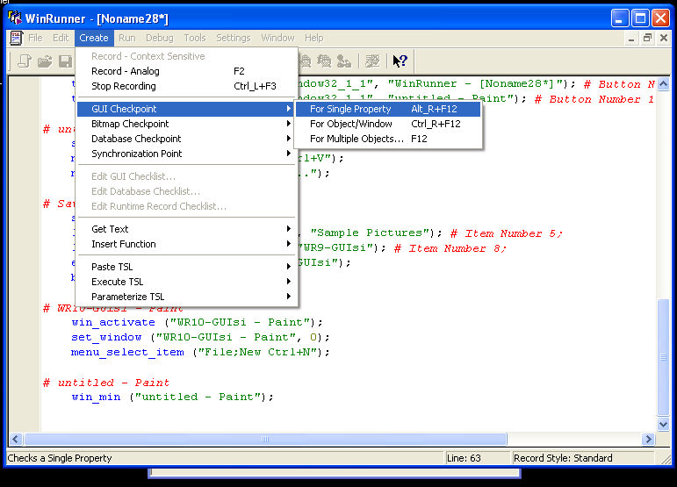

STEP-4: Run from Top and WinRunner Test Results window opens.

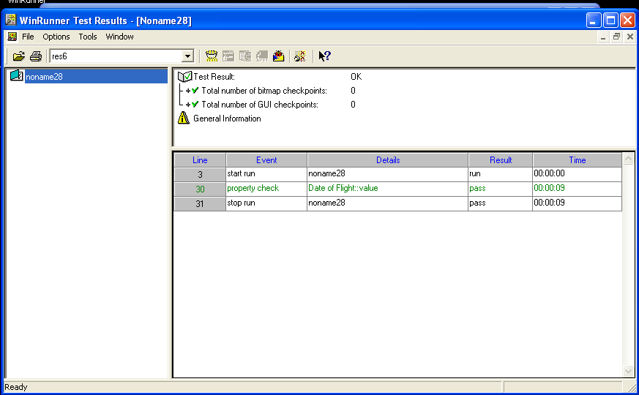

STEP-5: Click on “property check” row. A window opens comparing the expected and actual values.

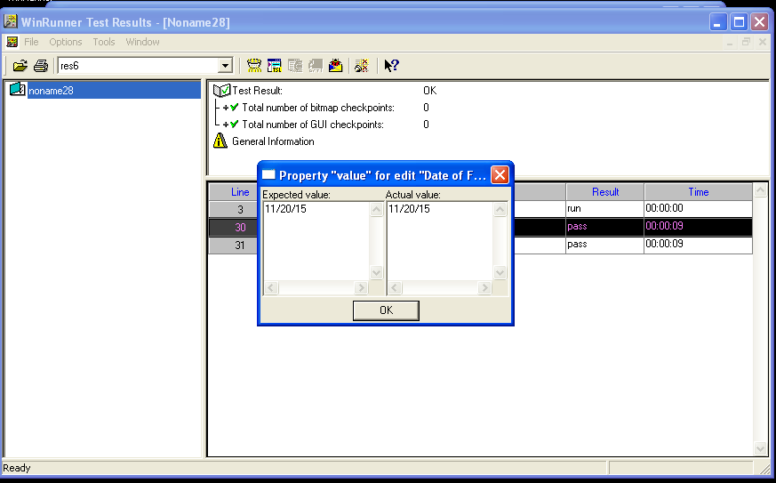

1. **GUI checkpoint for single object/window:** The checkpoint checks a single object or window in your application. For a GUI object class, WinRunner inserts an obj_check_gui statement, which compares current GUI object data to expected data.

STEP-1: Set Context sensitive mode.

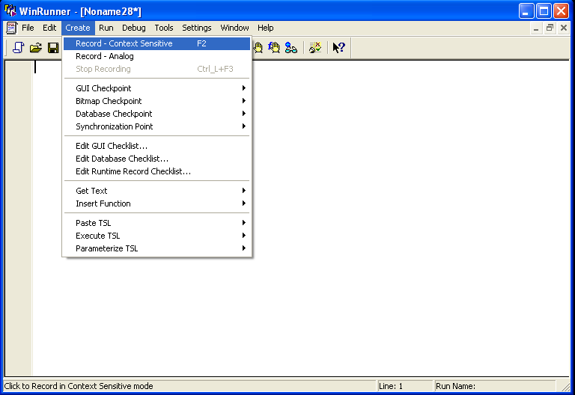

STEP-2: Open Flight Application and Insert an order. Don’t close the Flight Reservation window.



STEP-3: In WinRunner, goto **Create->GUI Checkpoint->For Object/Window**. Select any object/window in the Flight Reservation window and “Right click” on mouse.

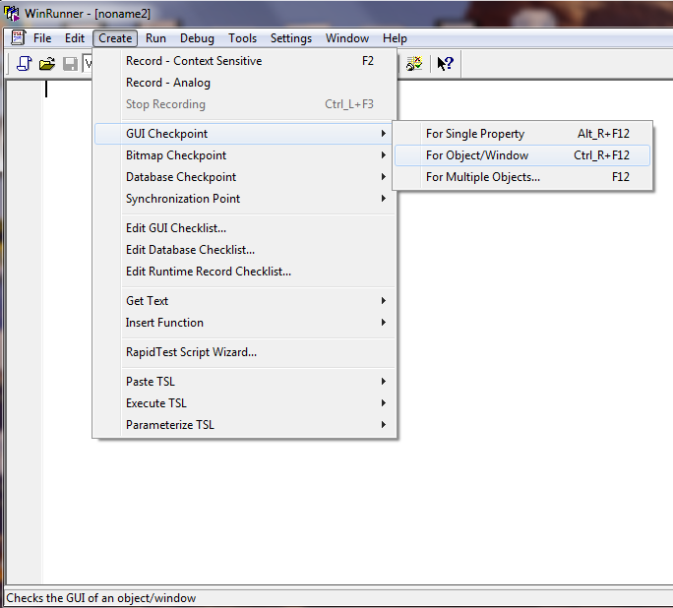

STEP-4: Run from Top and WinRunner Test Results window opens.

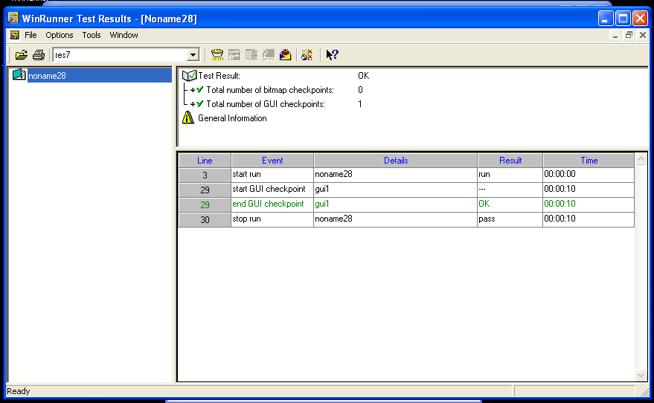

STEP-5: Click on “end GUI checkpoint” row. A window opens comparing the properties’ expected and actual values of the object/window selected.

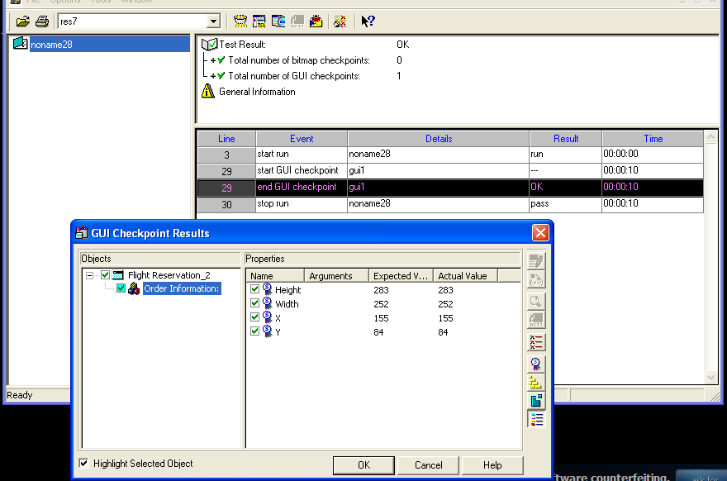

1. **GUI checkpoint for multiple objects:**The checkpoint checks multiple objects in your application. The checkpoint statement inserted by the WinRunner in the case of GUI checkpoint for multiple objects and GUI checkpoint for object/window are the same.   
   The Create GUI Checkpoint dialog box reopens. The Objects pane contains the name of the window and objects included in the GUI checkpoint. To specify which objects to check, click an object name in the Objects pane. The Properties pane lists all the properties of the object. The default properties are selected.

STEP-1: Set Context sensitive mode.



STEP-2: Open Flight Application and Insert an order. Don’t close the Flight Reservation window.

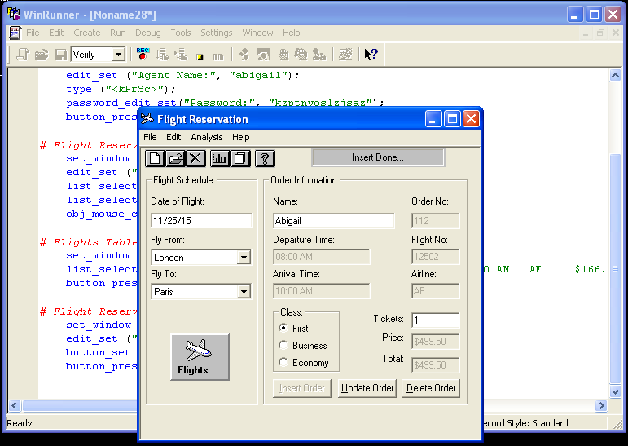

STEP-3: In WinRunner, goto **Create->GUI Checkpoint->For Object/Window**.

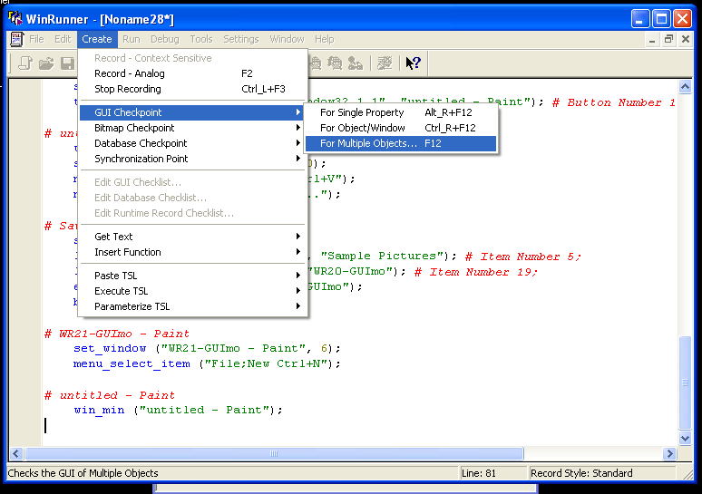

STEP-4: To add an object, click the **Add** button once. Select any number of objects in the Flight Reservation window and “Right click” on mouse to stop the selection process and to restore the mouse pointer to its original shape.

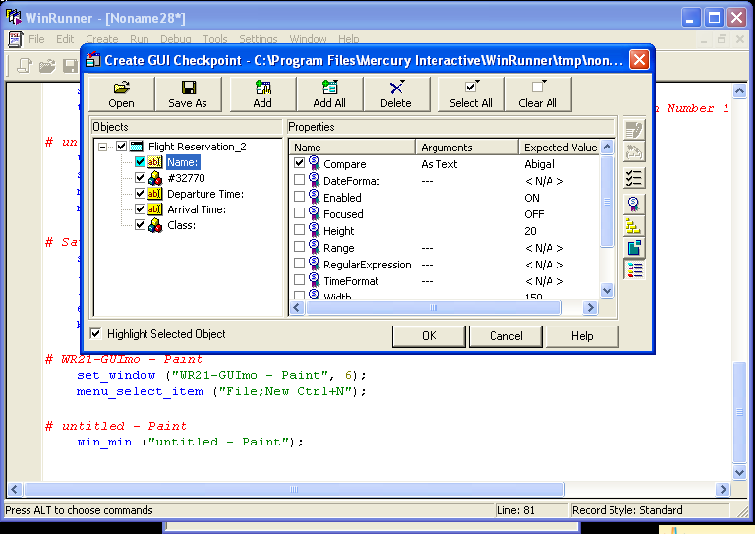

STEP-5: Run from Top and WinRunner Test Results window opens.

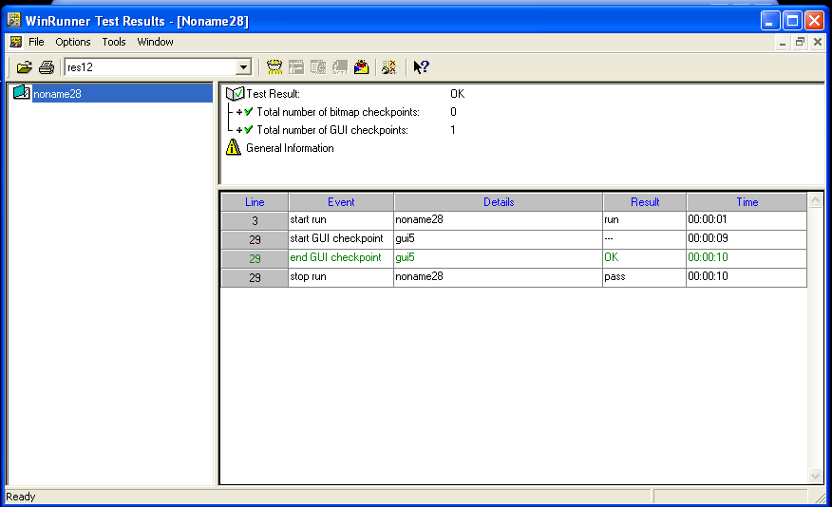

STEP-6: Click on “end GUI checkpoint” row. A window opens comparing the properties’ expected and actual values of the objects selected.

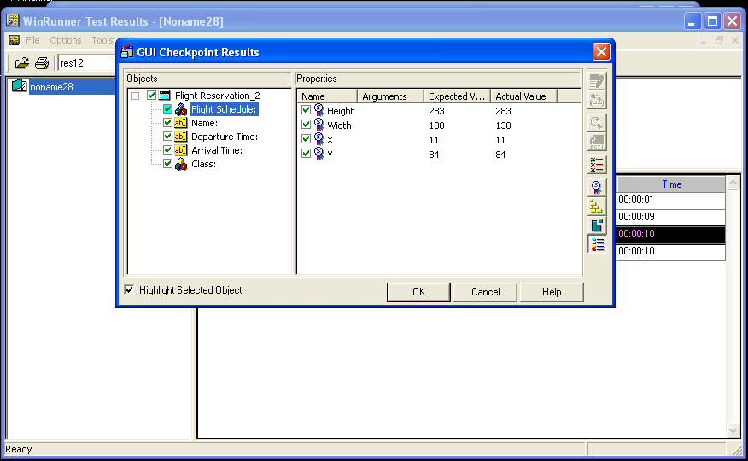

STEP-7: You can select each object separately and the comparison of the properties’ expected and actual values of the object is displayed. E.g. “Name” object is selected in the shown Figure.

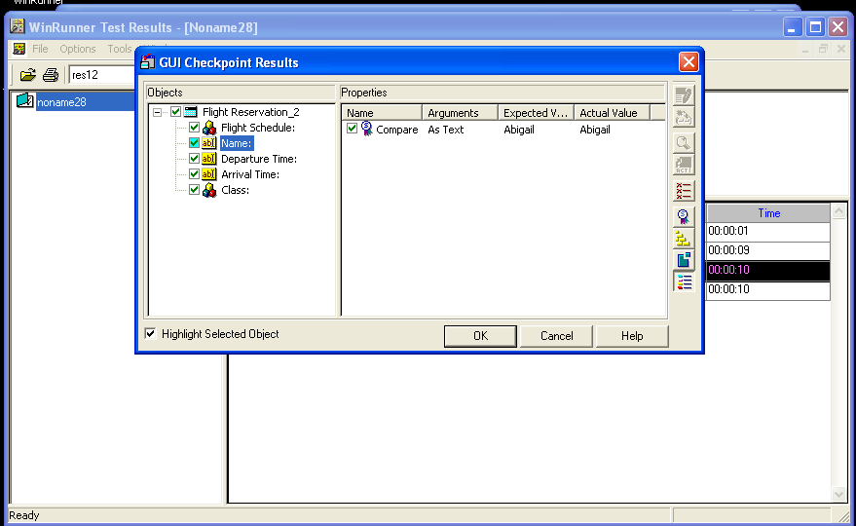

STEP-8: Select “Departure Time” object.

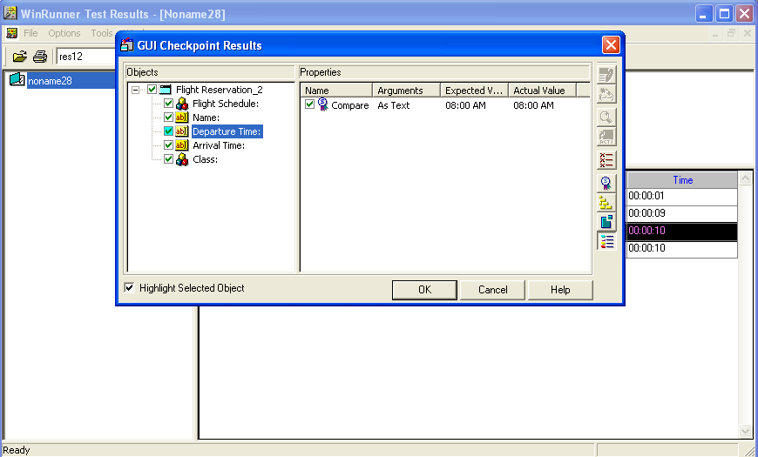

**TASK-3:**

1. BITMAP CHECKPOINT FOR SINGLE OBJECT/WINDOW.
2. BITMAP CHECKPOINT FOR SREEN AREA.

**Bitmap Checkpoint**: Bitmap Checkpoint checks an object, a window, or an area of a screen in the application as a bitmap. While creating a test, user can indicate what user want to check. WinRunner captures the specified bitmap, stores it in the expected results folder (exp) of the test, and inserts a checkpoint in the test script. While running the test, WinRunner compares the bitmap currently displayed in the application being tested with the expected bitmap stored earlier. In the event of a mismatch, WinRunner captures the current actual bitmap and generates a difference bitmap.

1. **For Single Object/Window:** Inserts a bitmap checkpoint into your test script. The checkpoint checks a single object or window in your application.

STEP-1: Set Context sensitive mode.

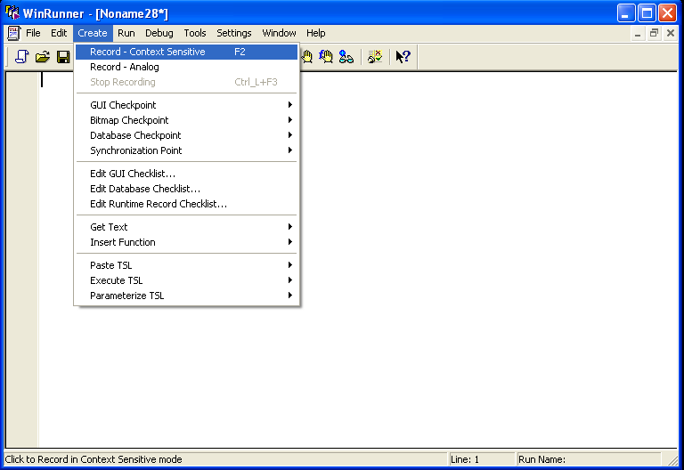

STEP-2: Open a picture. Don’t close it.

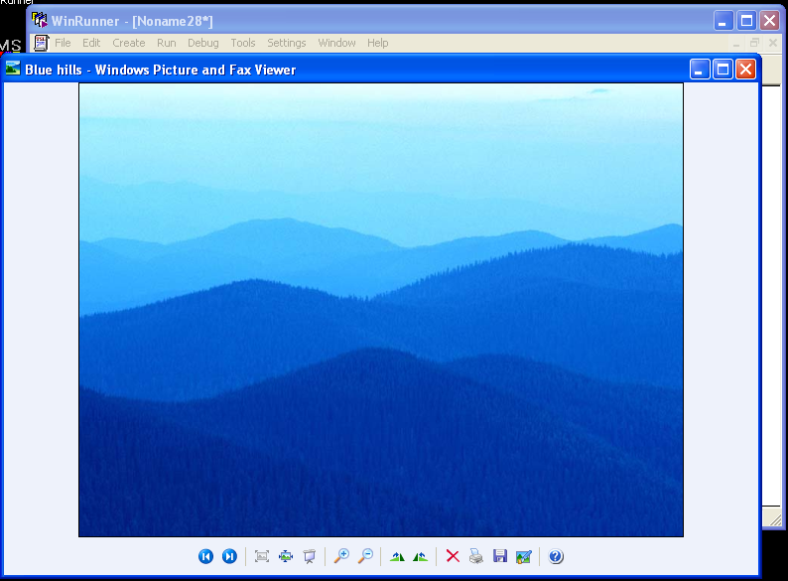

STEP-3: In WinRunner, goto **Create->BITMAP Checkpoint->For Object/Window**.

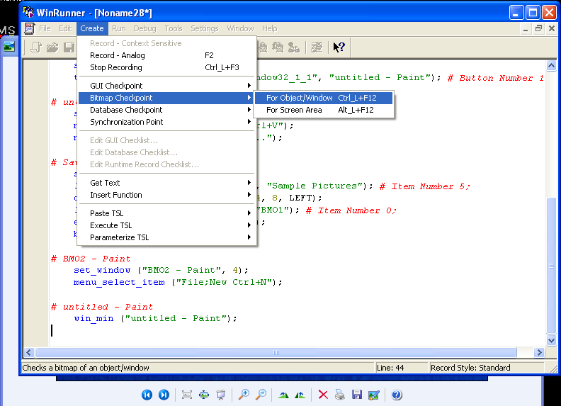

STEP-4: Run from Top and WinRunner Test Results window opens.

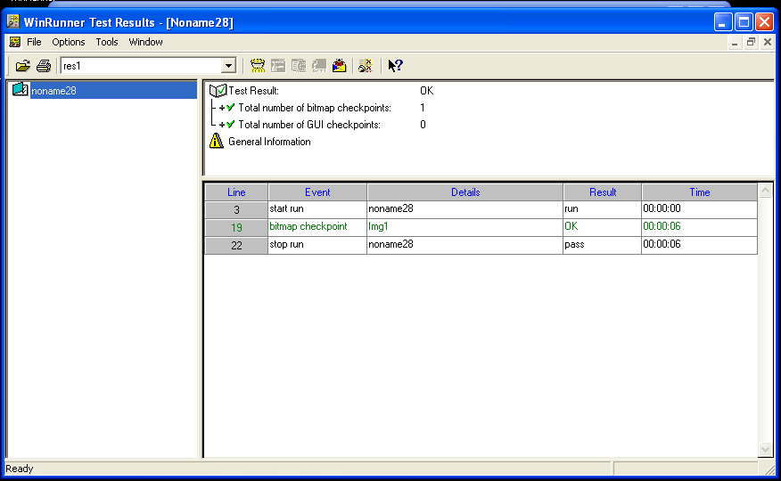

STEP-5: Click on “bitmap checkpoint” row. A window opens showing the expected value of the object/window selected.

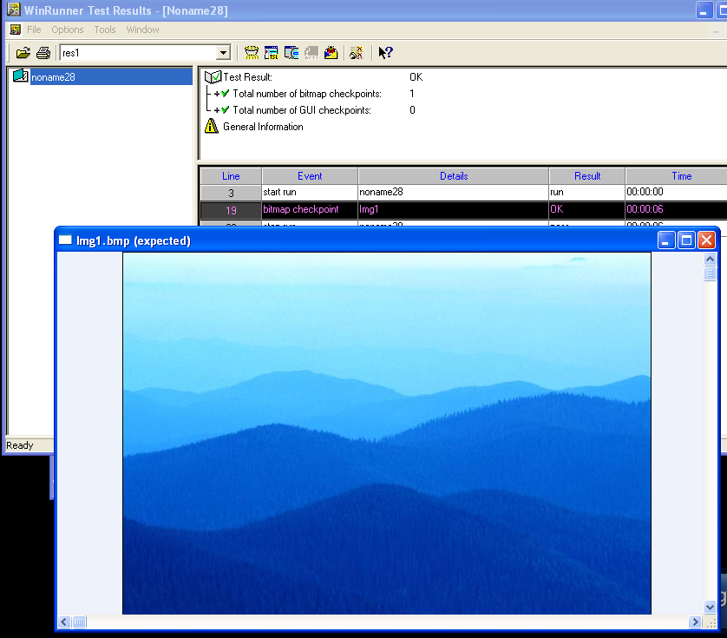

1. **For Screen Area:** -User defines any rectangular area of the screen and captures it as a bitmap for comparison.

STEP-1: Set Context sensitive mode.

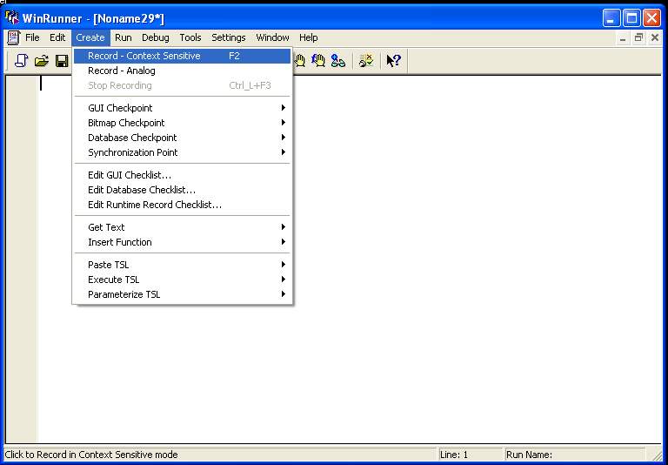

STEP-2: In WinRunner, goto **Create->BITMAP Checkpoint->For Screen Area.** Select a portion of screen area and **Right click** on mouse.

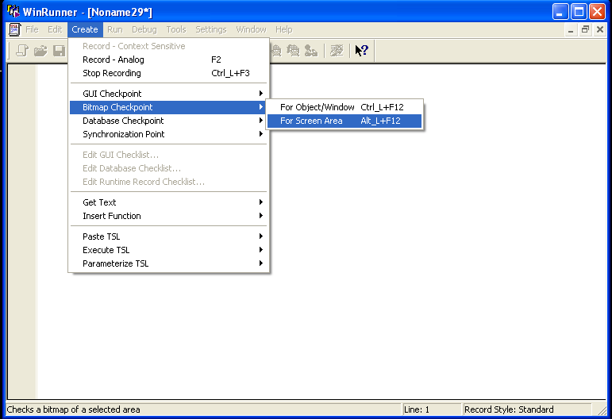

STEP-3: Run from Top.

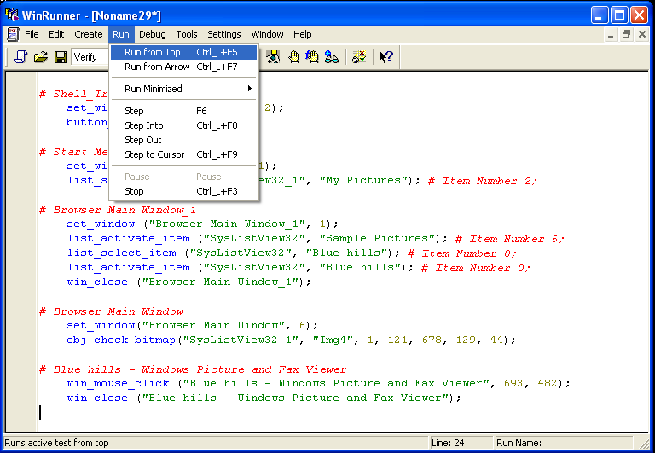

STEP-4: WinRunner Test Results window opens.

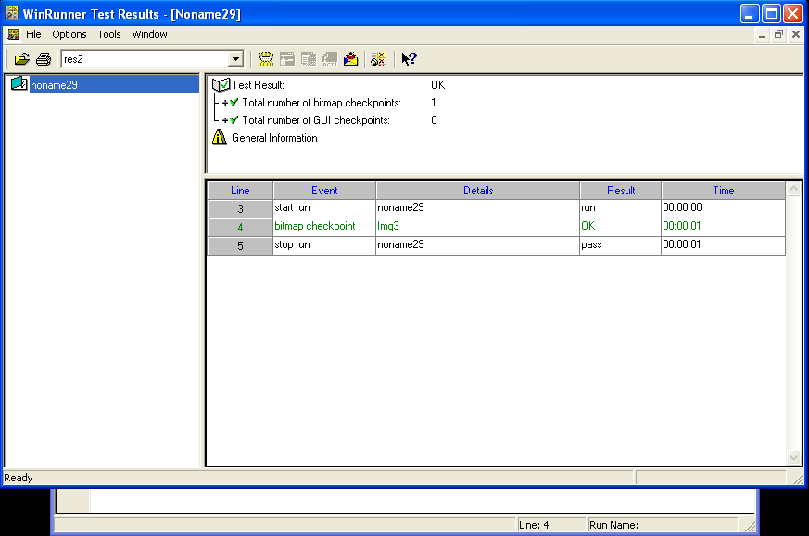

STEP-5: Click on “bitmap checkpoint” row. A window opens showing the expected value of the screen area selected.

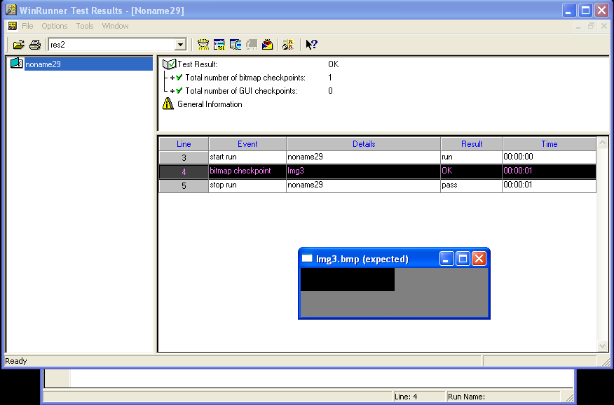

**TASK-4:**

1. DATABASE CHECKPOINT FOR DEFAULT CHECK.
2. DATABASE CHECKPOINT FOR CUSTOM CHECK.
3. DATABASE CHECKPOINT FOR RUNTIME RECORD CHECK.

**Database Checkpoint**:

1. **Default Check:** Inserts a database checkpoint into your test script. Use a default database check to check the entire contents of a database associated with your application.

STEP-1: Set Context sensitive mode.

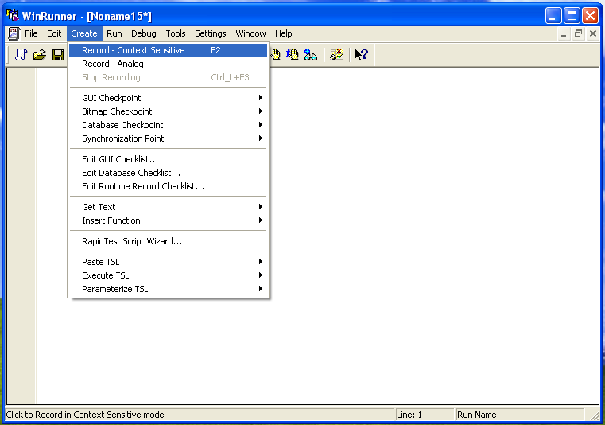

STEP-2: Goto Database Checkpoint->Custom Check

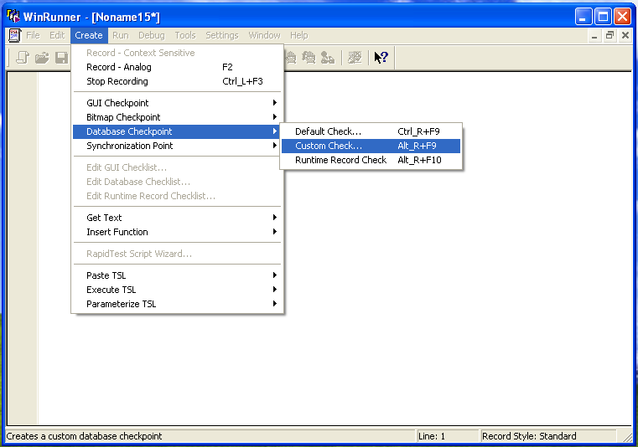

STEP-3: Database Checkpoint Wizard opens. Select **Create new query** and **Finish**.

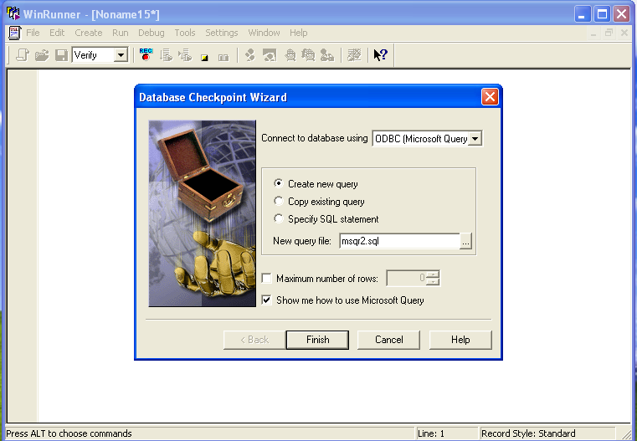

STEP-4: A window of **Instructions for Microsoft Query** opens. Click OK.

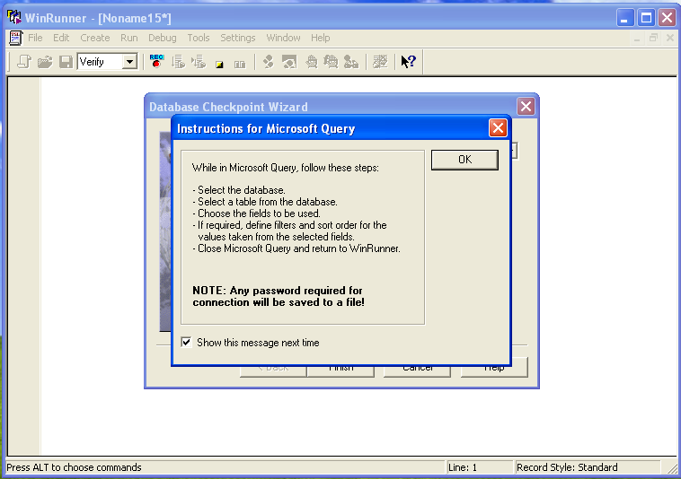

STEP-5: A window opens asking you to **Choose** **Data Source**. Select Flight32* and click OK.

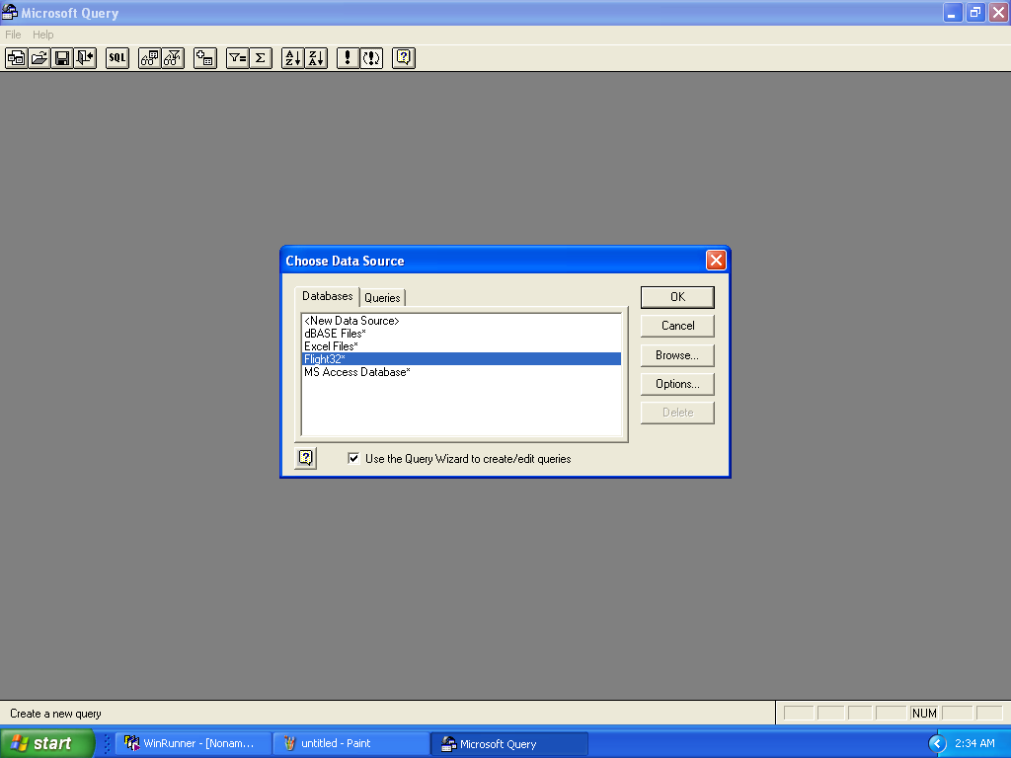

STEP-6: Query Wizard opens. You can select **Available tables and columns** and add them to your query by pressing on ‘**>**’.

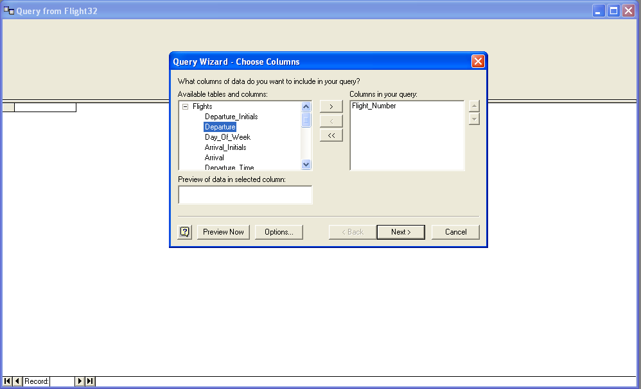

STEP-7: Add the tables and columns you would like to add and click **Next.**

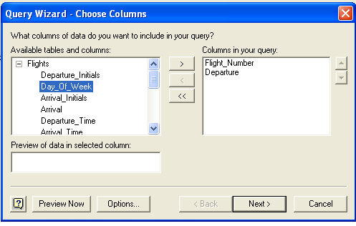

STEP-8: Specify the conditions for obtaining the desired information.

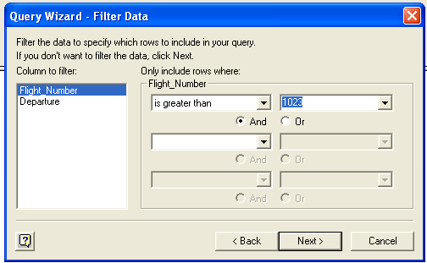

STEP-9: Specify conditions for all the selected tables and columns and Click **Next**.

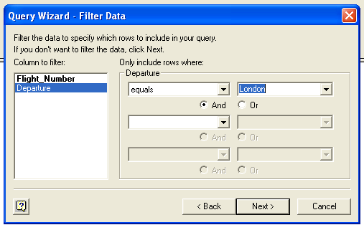

STEP-10: Specify the sorting order you want and click **Next**.

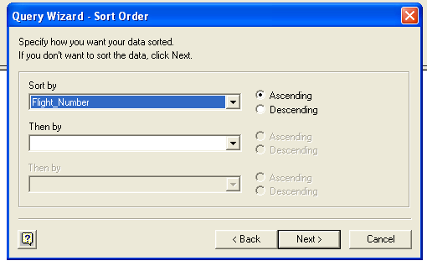

STEP-11: Click **Finish.**

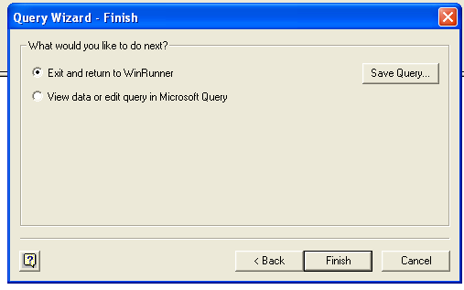

STEP-12: Check Database window opens. Click OK.

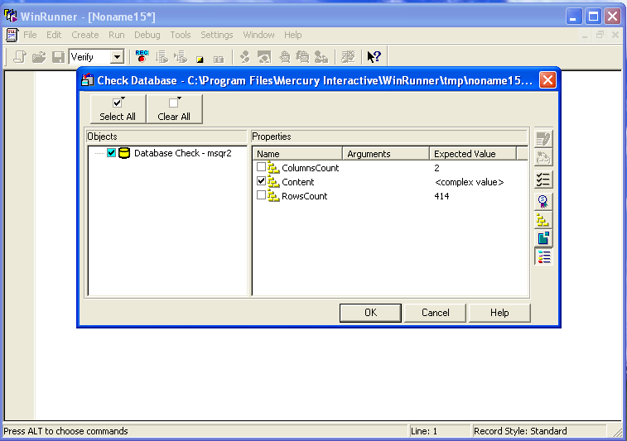

STEP-13: Stop the process.

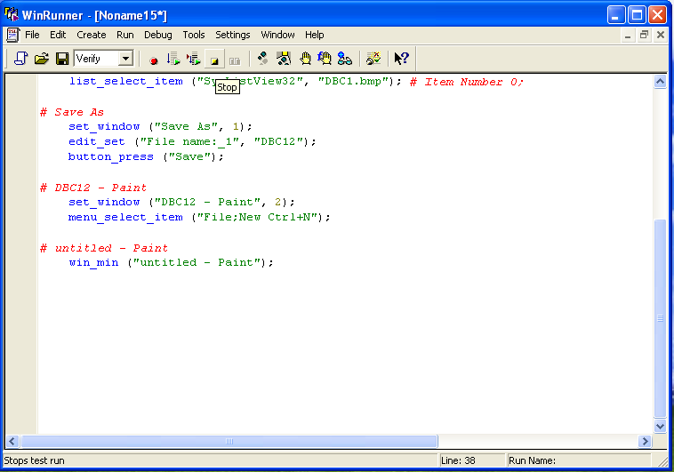

STEP-14: Run from Top.

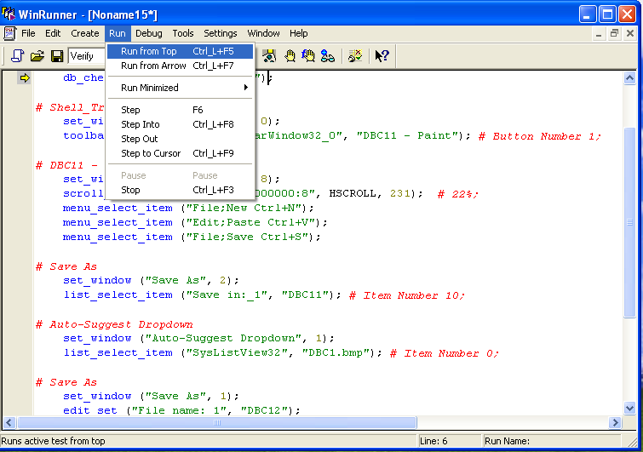

STEP-15: Click OK.

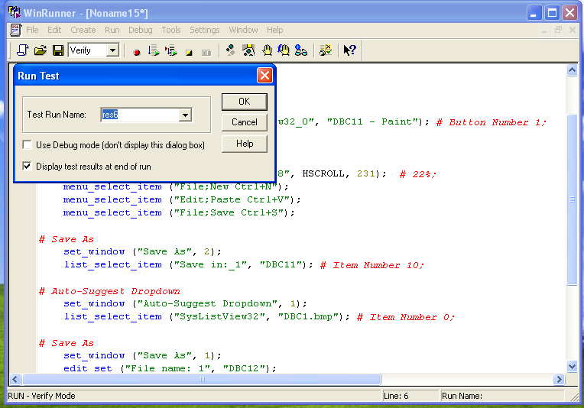

STEP-16: Click on “end database checkpoint” row.

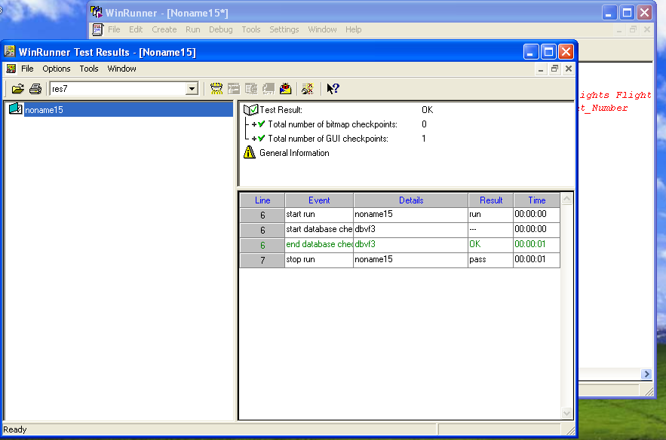

STEP-17: **Database Checkpoint Results** window opens. Click on the “Content” row.

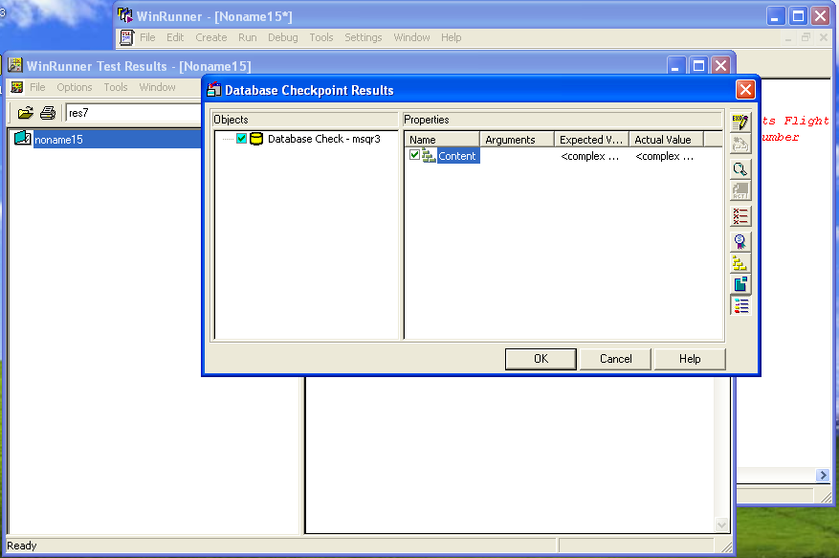

STEP-18: **Data Comparison Viewer** window opens where Expected data and Actual data is displayed.

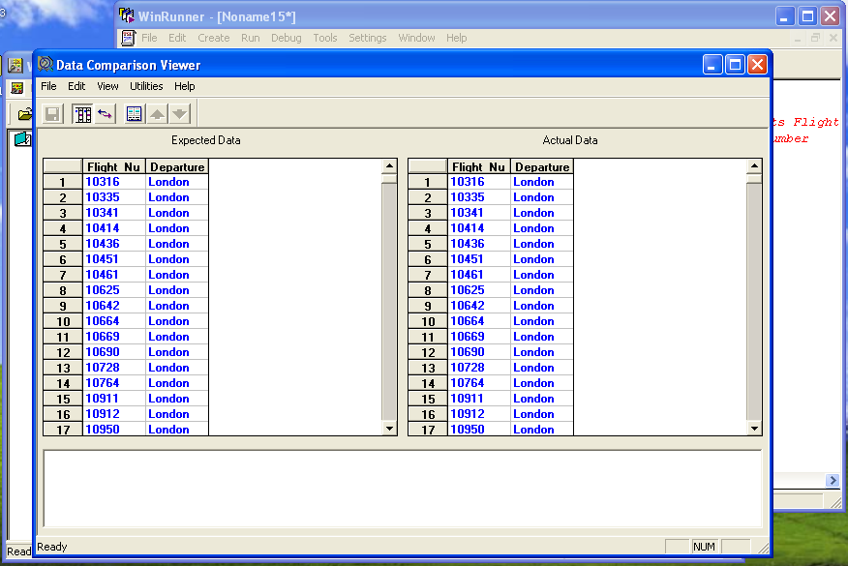

1. **Custom Check:** Inserts a database checkpoint into your test script. The checkpoint checks specified properties of the database.

Use a custom check to:

· check the number of rows in a database

· check the number of columns in a database

· check specific information in the database

STEP-1: Set Context sensitive mode.

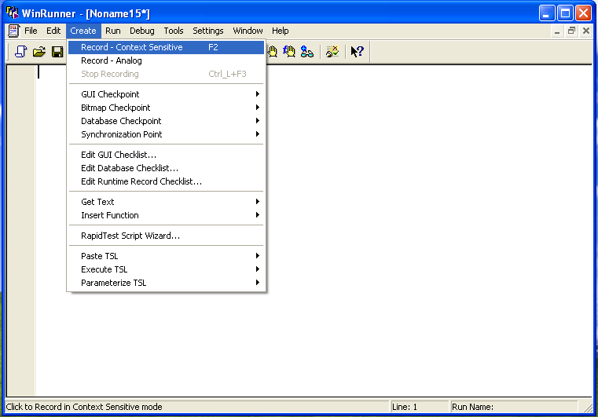

STEP-2: Goto Database Checkpoint->Default Check

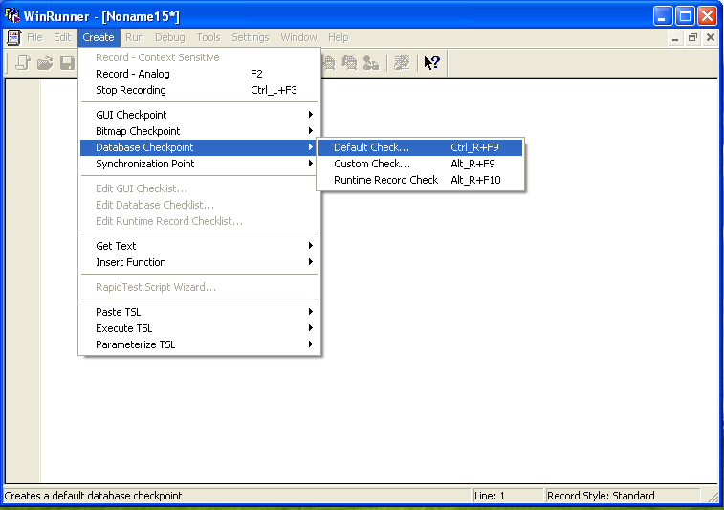

STEP-3: Database Checkpoint Wizard opens. Select **Create new query** and **Finish**.



STEP-4: A window of **Instructions for Microsoft Query** opens. Click OK.

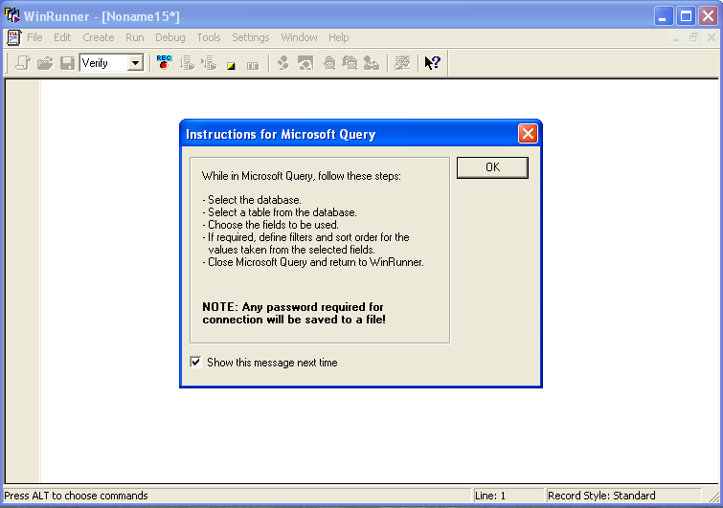

STEP-5: A window opens asking you to **Choose** **Data Source**. Select Flight32* and click OK.

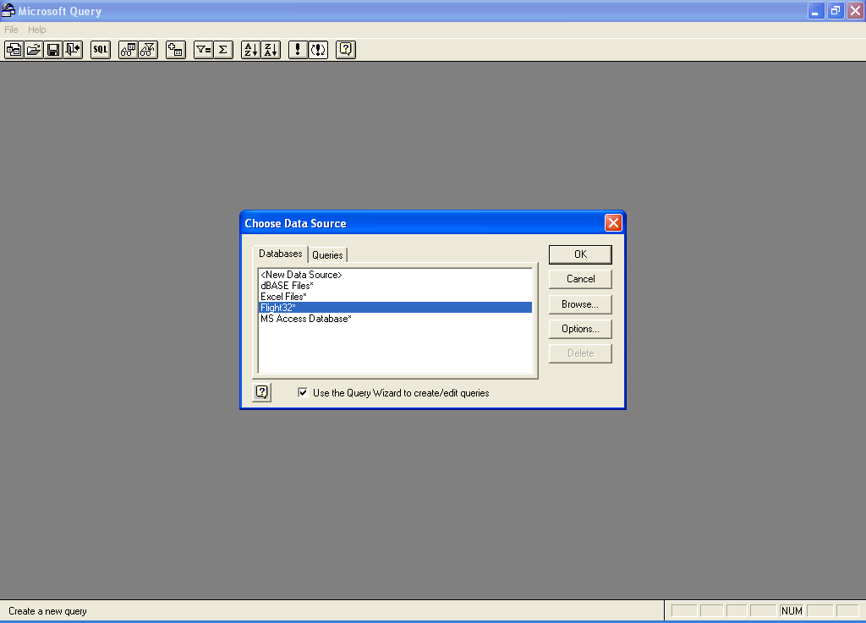

STEP-6: Query Wizard opens. You can select **Available tables and columns** and add them to your query by pressing on ‘**>**’. Add the tables and columns you would like to add and click **Next.**

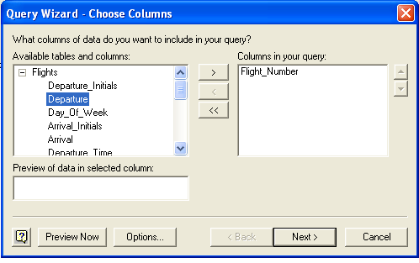

STEP-7: Specify the conditions for obtaining the desired information.

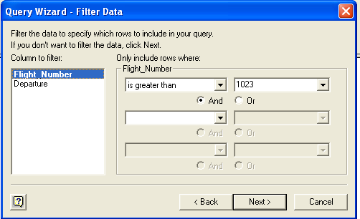

STEP-8: : Specify conditions for all the selected tables and columns and Click **Next**.

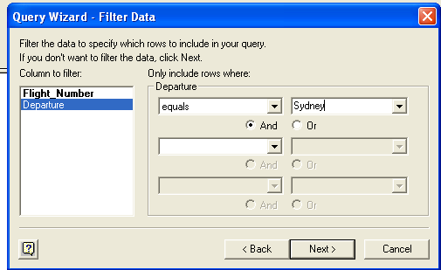

STEP-9: Specify the sorting order you want and click **Next**.

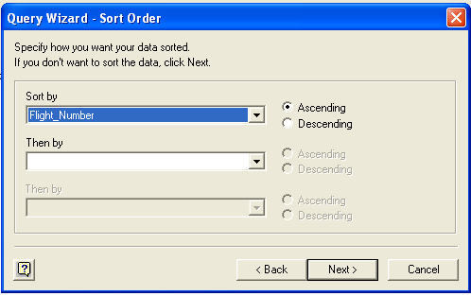

STEP-10: Click **Finish.**

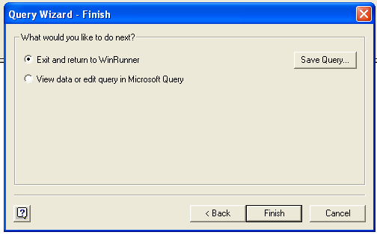

STEP-11: Stop the process.

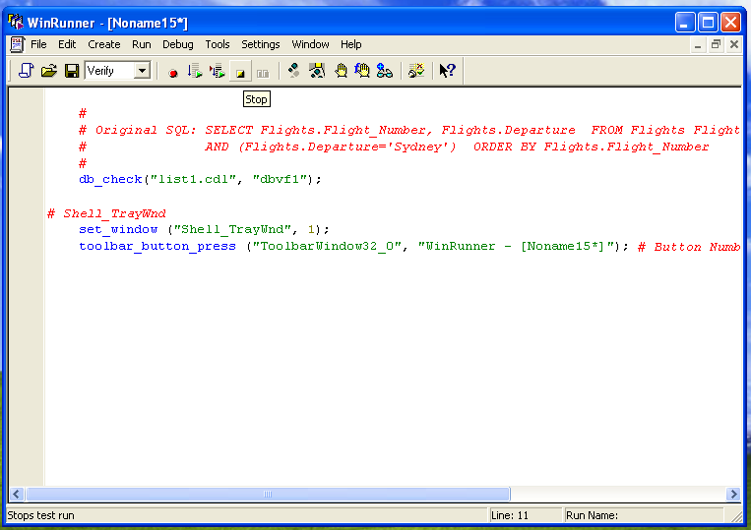

STEP-12: Run from Top.

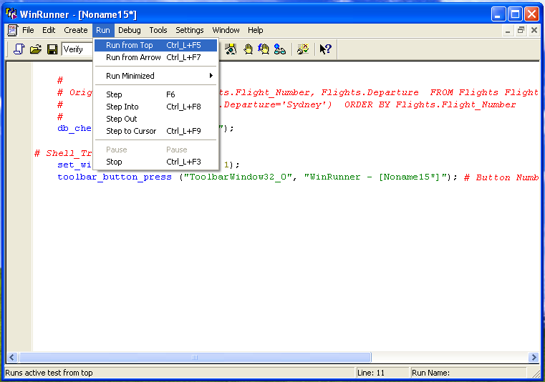

STEP-13: Click on “end database checkpoint” row.

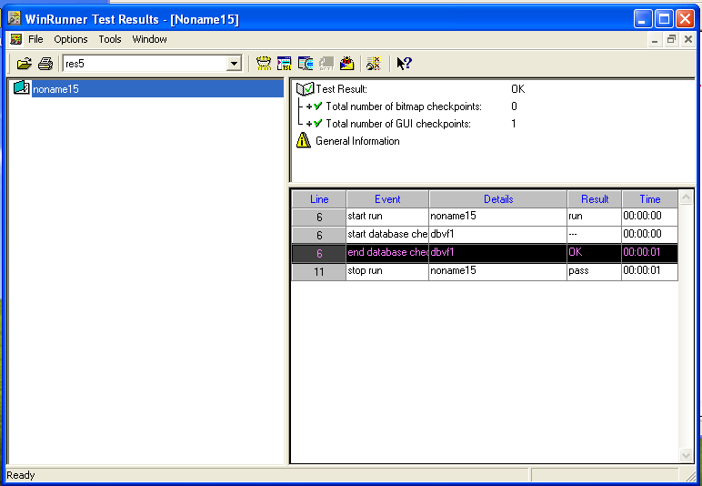

STEP-14: **Database Checkpoint Results** window opens. Click on the “Content” row.

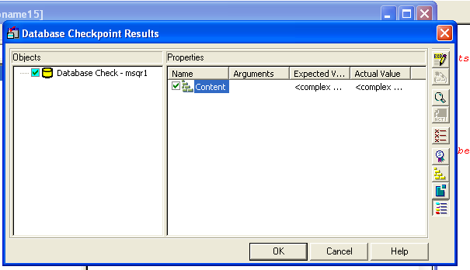

STEP-15: **Data Comparison Viewer** window opens where Expected data and Actual data is displayed.

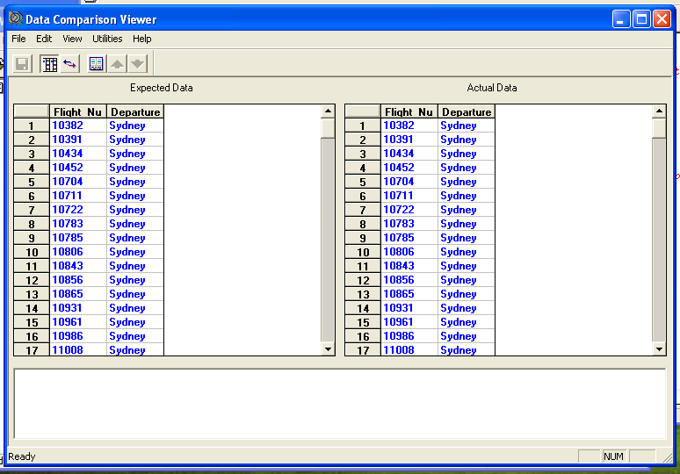

1. **Run Time Record Check:** The Runtime Record Checkpoint wizard, which enables you to insert a Runtime Database Record checkpoint into your test script. The checkpoint captures information from your application during the test run and checks it against the corresponding record(s) in the database.

STEP-1: Set Context sensitive mode.



STEP-2:Open Flight Reservation application, a **Login** window opens.



STEP-3: Fill in your desired **Agent Name** and “mercury” as **Password.**



STEP-4:Fill in the details for flight reservation and press “Insert Order”.

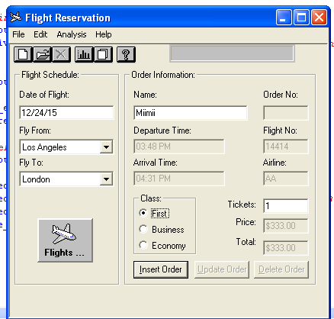

STEP-5:Goto **Create->Database Checkpoint->Runtime Record Check**.

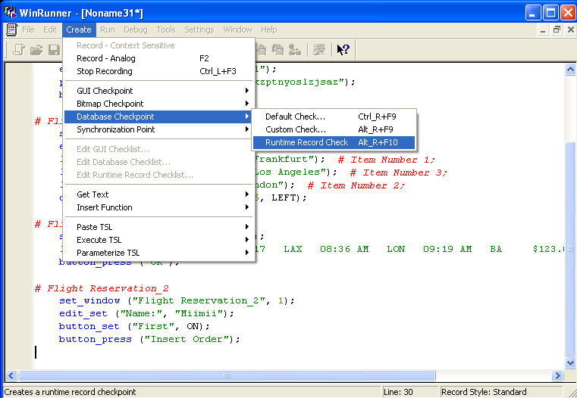

STEP-6:**Create new query->Next**.

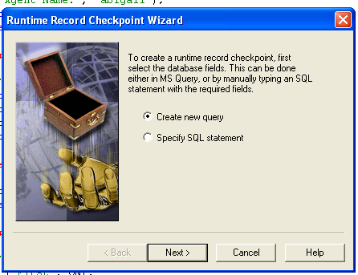

STEP-7:Select **Flight 32->OK**.



STEP-8: Select **Order->Customer_Name->Click “>”->Next**.

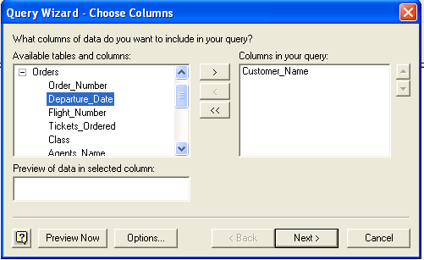

STEP-9: Filter using “like” option->Select Name->Next.

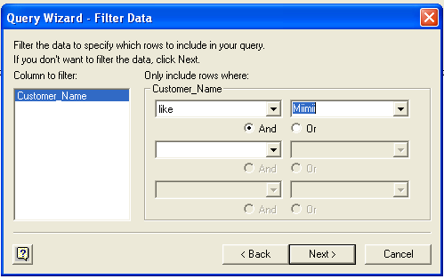

STEP-10:Sort by Customer_Name->Next->Finish.

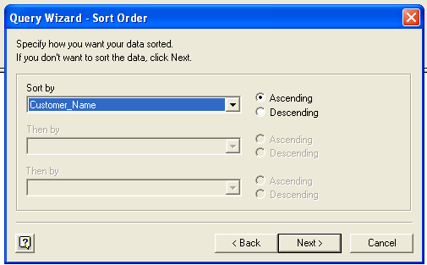

STEP-11:Click on “hand” icon-> Select Customer_Name->Next->Finish->Close Flight 1A->Stop the process

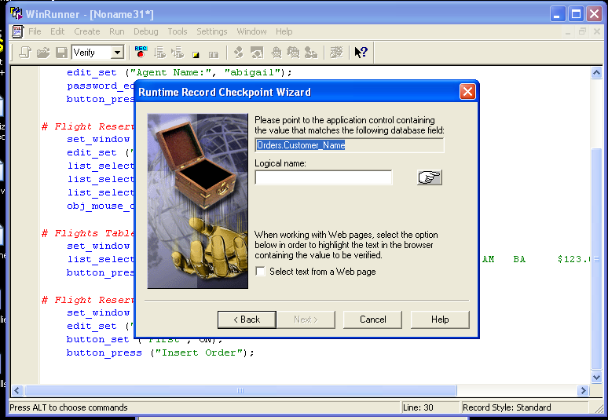

STEP-12: Run from Top-> Test results->Click on “end database runtime record” row.

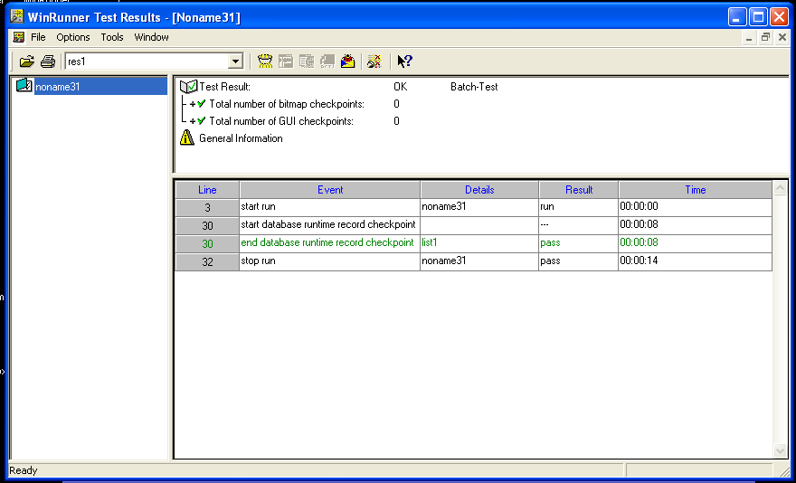

STEP-13: Database checkpoint results open.

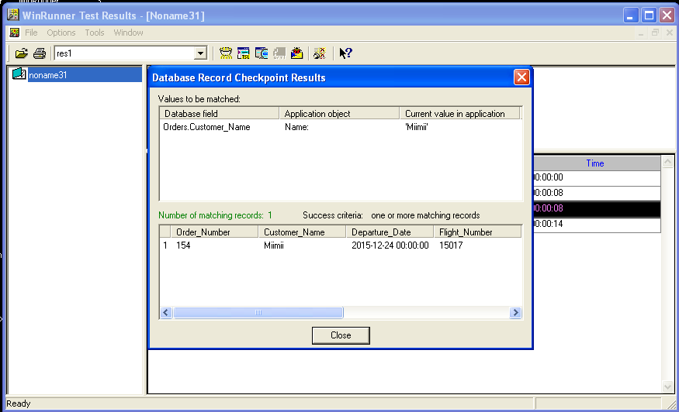

**TASK-5:**

1. DATA DRIVEN TEST FOR DYNAMIC DATA SUBMISSION.
2. DATA DRIVEN TEST THROUGH FLAT FILES.
3. DATA DRIVEN TEST THROUGH EXCEL SHEETS.

**Data driven test:**

1. **For dynamic data submission:** Sometimes a test engineer conducts retesting with different input values to validate the calculation through dynamic submission. For this input submission, test engineer use this function in TSL script-- create_input_dialog ("label");

STEP-1: Set Context sensitive mode.



STEP-2:Open Flight Reservation application, a **Login** window opens.



STEP-3: Fill in your desired **Agent Name** and “mercury” as **Password.**



STEP-4:Fill in the details for flight reservation and press “Insert Order”->Close Flight 1A->Stop the process->Save the test.

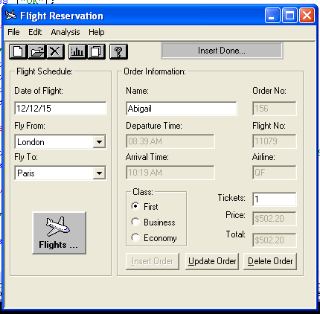

STEP-5:Goto **Tools->DataDriver Wizard**.

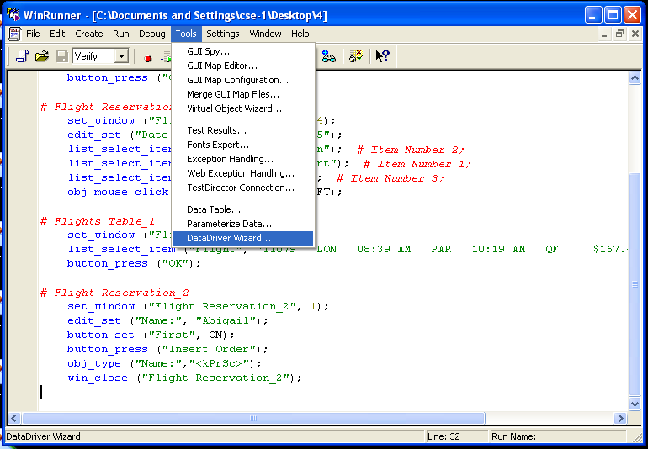

STEP-6:A window opens->Next.

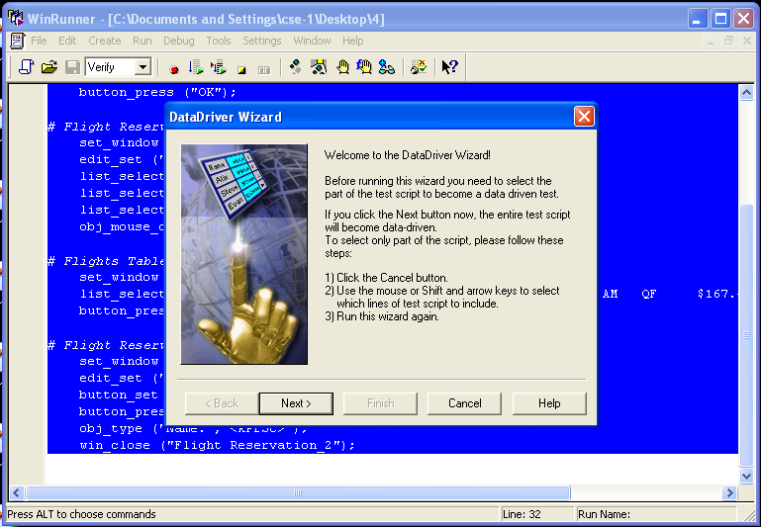

STEP-7: Type the file name you want with extension “.xls”, ”.doc” or “.txt”->**Next**.

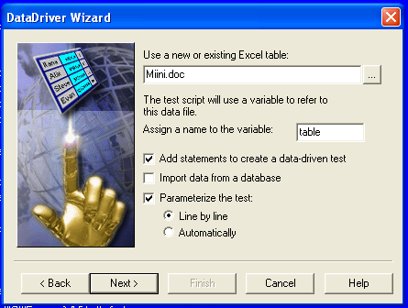

STEP-8: TSL script keeps coming**->Click Next->Select A new column** to change parameter**->Next->Skip**.

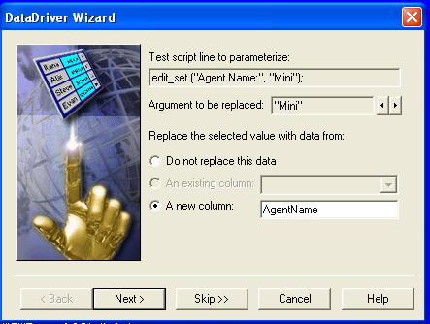

STEP-9: Select **Show data table now**->**Finish**.

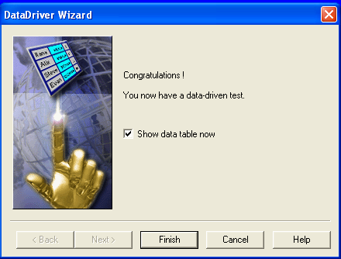

STEP-10: Data table opens->Enter any values you want in the data table->Close.

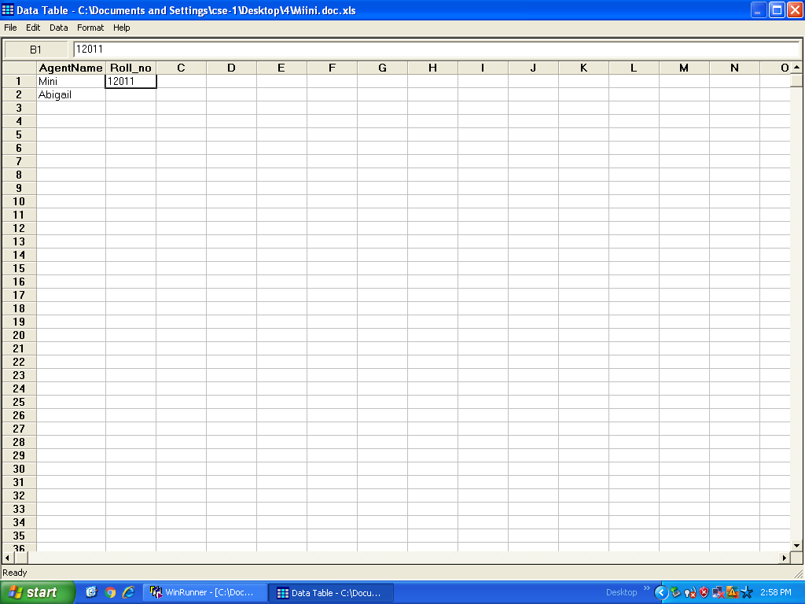

STEP-11: Goto saved test folder->Open the file you saved.

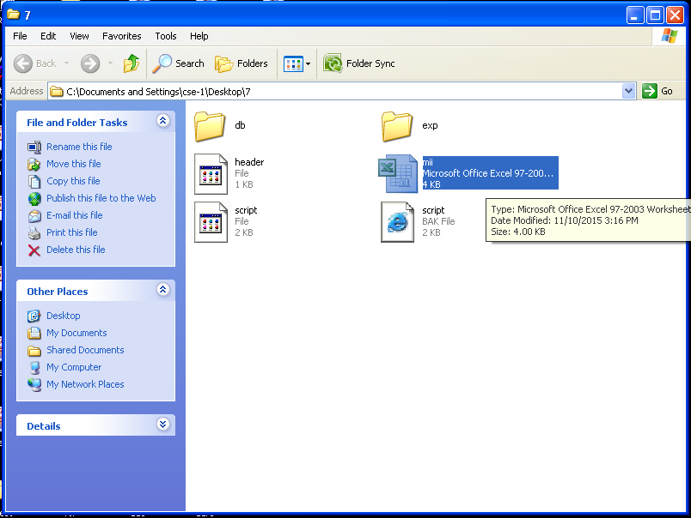

STEP-12: Values you changed will be in it.

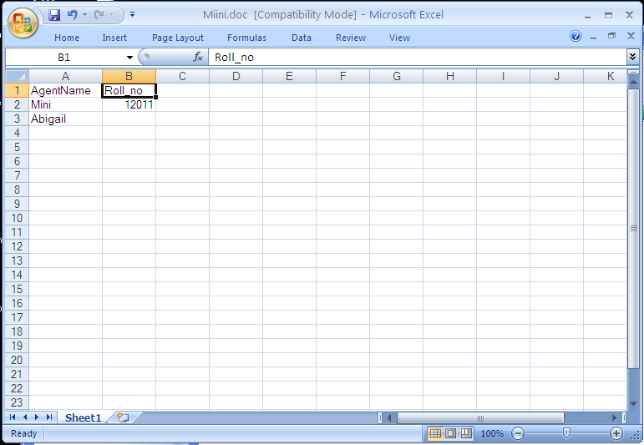

1. **Through flat files:** Sometimes test engineer conducts re-testing depends on flat file contents. He collect these files from Old Version databases or from customer side.

STEP-1: Set Context sensitive mode.



STEP-2:Open Flight Reservation application, a **Login** window opens.



STEP-3: Fill in your desired **Agent Name** and “mercury” as **Password.**



STEP-4:Fill in the details for flight reservation and press “Insert Order”->Close Flight 1A->Stop the process->Save the test.

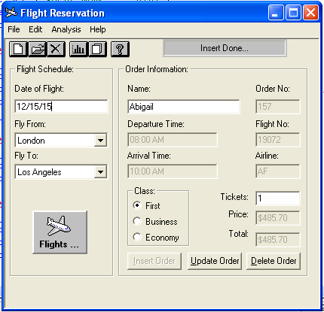

STEP-5:Goto **Tools->DataDriver Wizard**.



STEP-6:A window opens->Next.

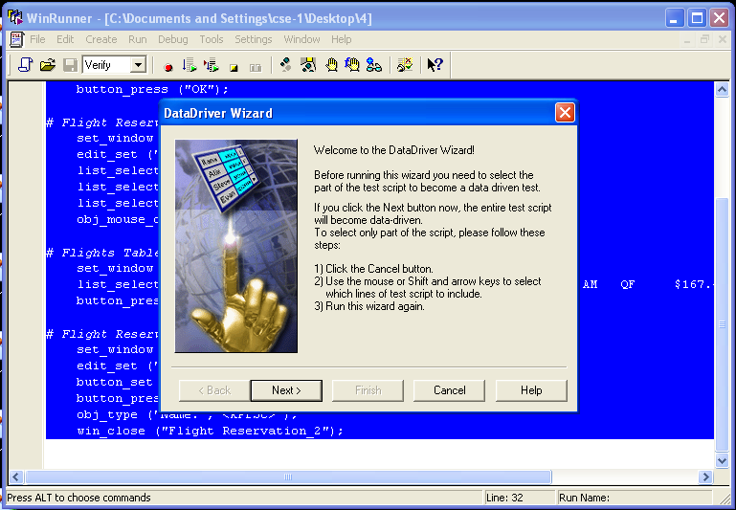

STEP-7: Type the file name you want with extension “.doc” or “.txt”->**Next**.

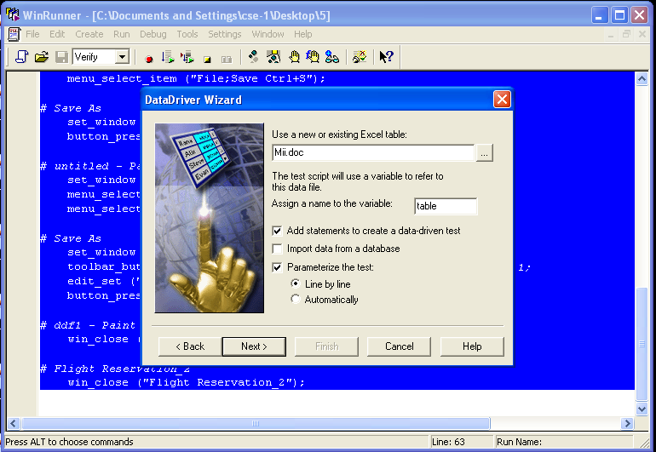

STEP-8: TSL script keeps coming**->Click Next->Select A new column** to change parameter**->Next->Skip**.

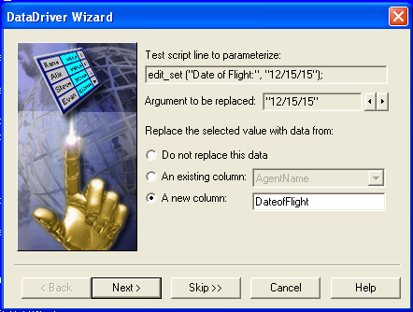

STEP-9: Select **Show data table now**->**Finish**.



STEP-10: Data table opens with changes you have made.

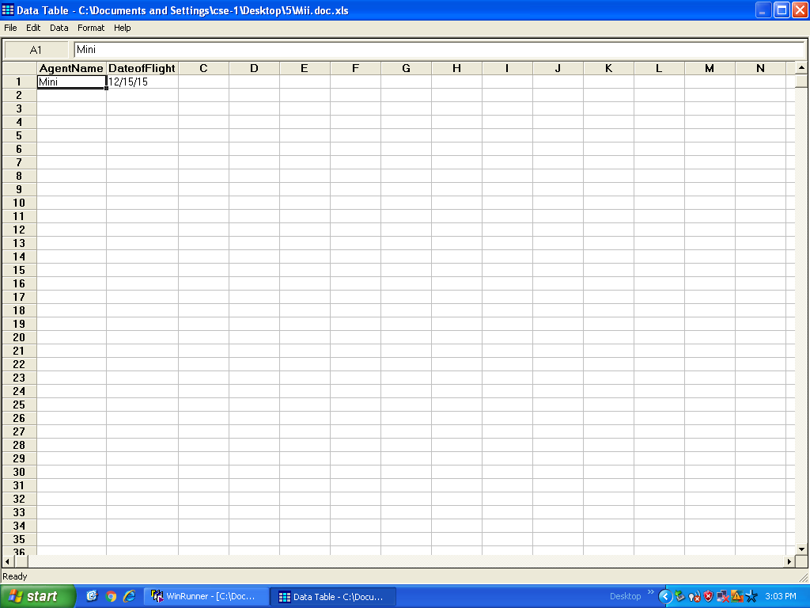

STEP-11: Goto saved test folder->Open the file you saved.

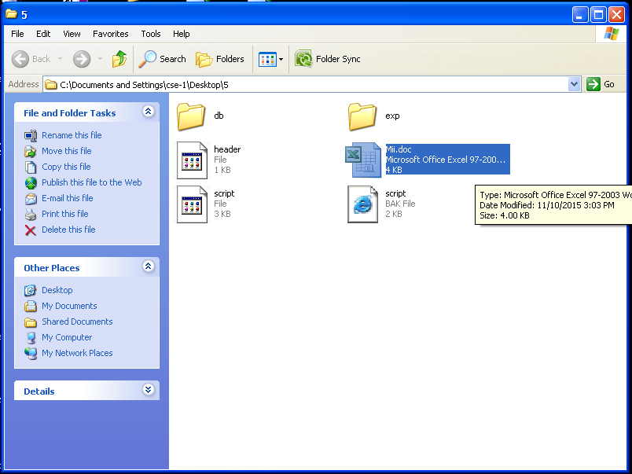

STEP-12: Values you changed will be in it.

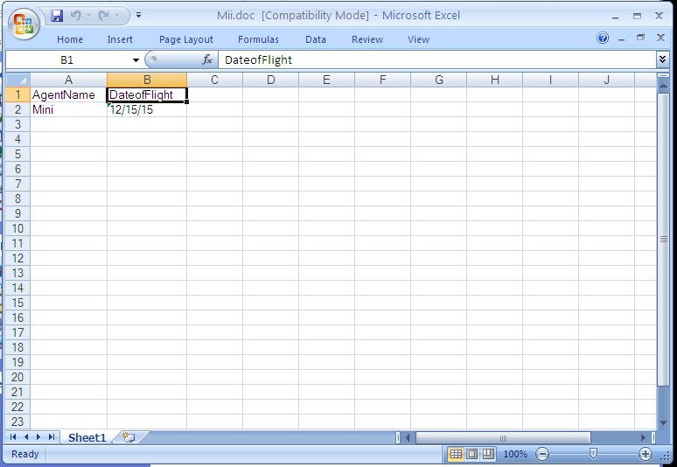

1. **Through excel sheets:** Sometimes a test engineer follows this type of data driven test to execute their script for multiple inputs. These multiple inputs consist in excel sheet columns. We have to collect this test data from backend tables.

STEP-1: Set Context sensitive mode.



STEP-2:Open Flight Reservation application, a **Login** window opens.



STEP-3: Fill in your desired **Agent Name** and “mercury” as **Password.**



STEP-4:Fill in the details for flight reservation and press “Insert Order”->Close Flight 1A->Stop the process->Save the test.

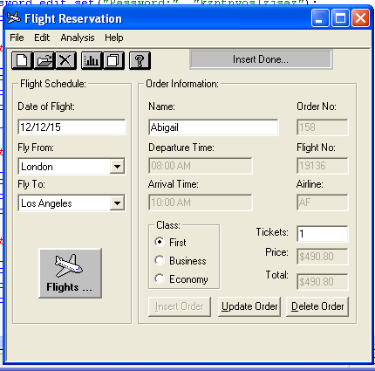

STEP-5:Goto **Tools->DataDriver Wizard**.

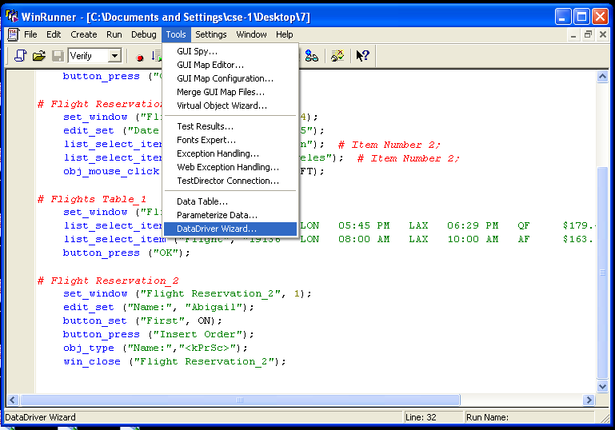

STEP-6:A window opens->Next.



STEP-7: Type the file name you want with extension “.xls”->**Next**.

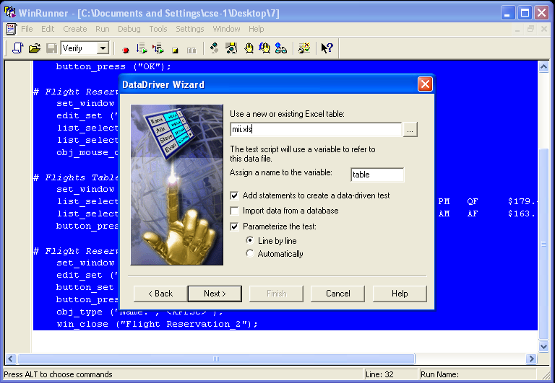

STEP-8: TSL script keeps coming**->Click Next->Select A new column** to change parameter**->Next->Skip**.

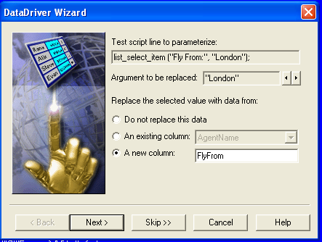

STEP-9: Select **Show data table now**->**Finish**.

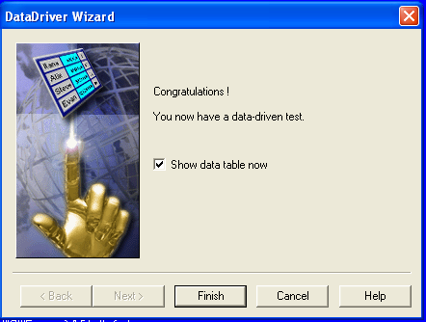

STEP-10: Data table opens with values you changed->Close.

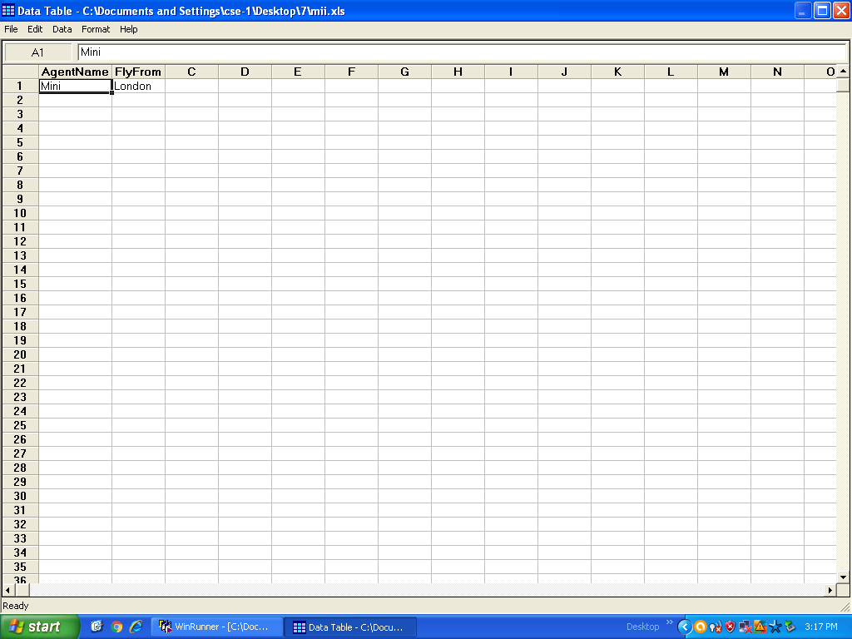

STEP-11: Goto saved test folder->Open the file you saved.



STEP-12: Values you changed will be in it.

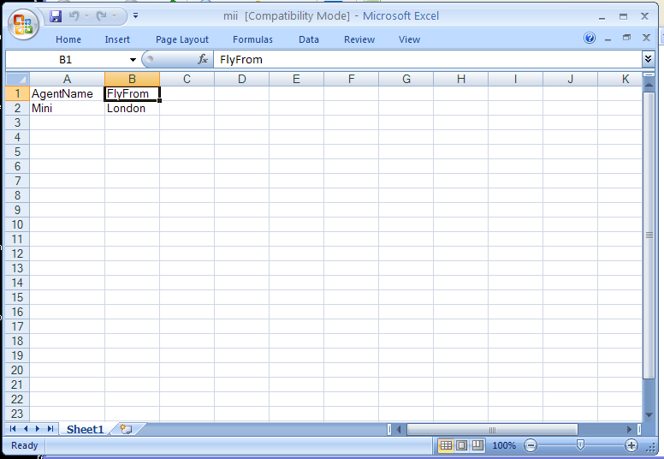

**TASK-6:**

1. BATCH TESTING WITHOUT PARAMETER PASSING.
2. BATCH TESTING WITH PARAMETER PASSING.
3. **Batch Test** **without parameter passing:** It is used to execute Multiple Tests in a single Batch Test.

**Syntax:**

Call “script1”();

Call “script2”();

Call “script3”();

Example:

call "c:\\qa\\flights\\lesson5"();

call "c:\\qa\\flights\\lesson6"();

call "c:\\qa\\flights\\lesson7"();

STEP-1: Open WinRunner. Two tests are saved with the names “2” and “3” on Desktop. Insert their paths in the syntax.

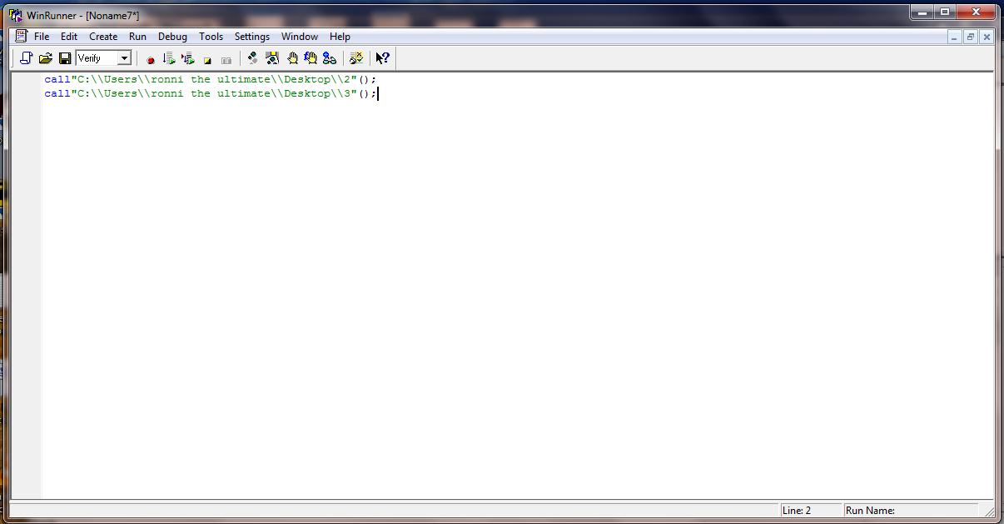

STEP-2: Run from Top

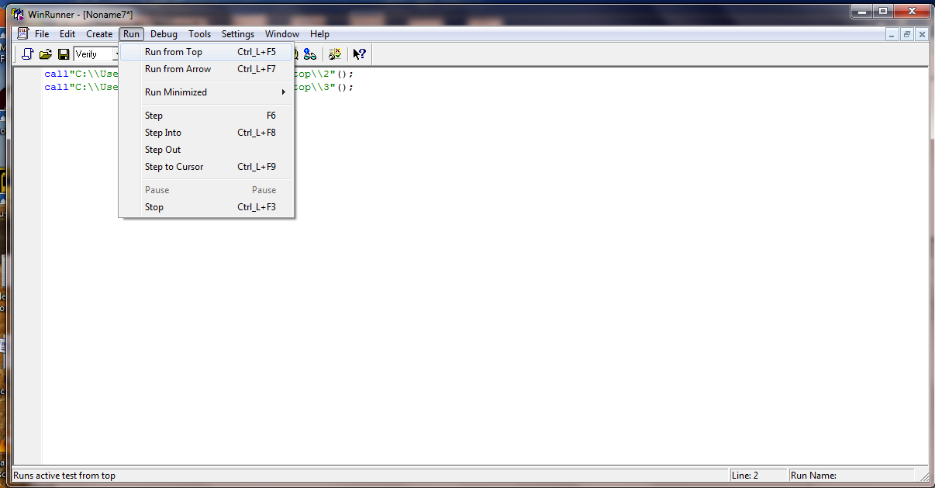

STEP-3: Both the tests are run one by one and their results are displayed.

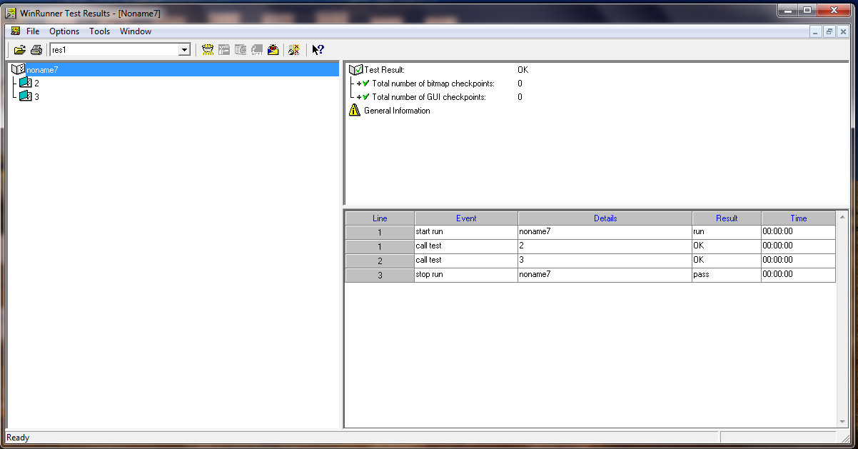

STEP-4: You can specifically select one test and view its results. Test “2” results are shown here.

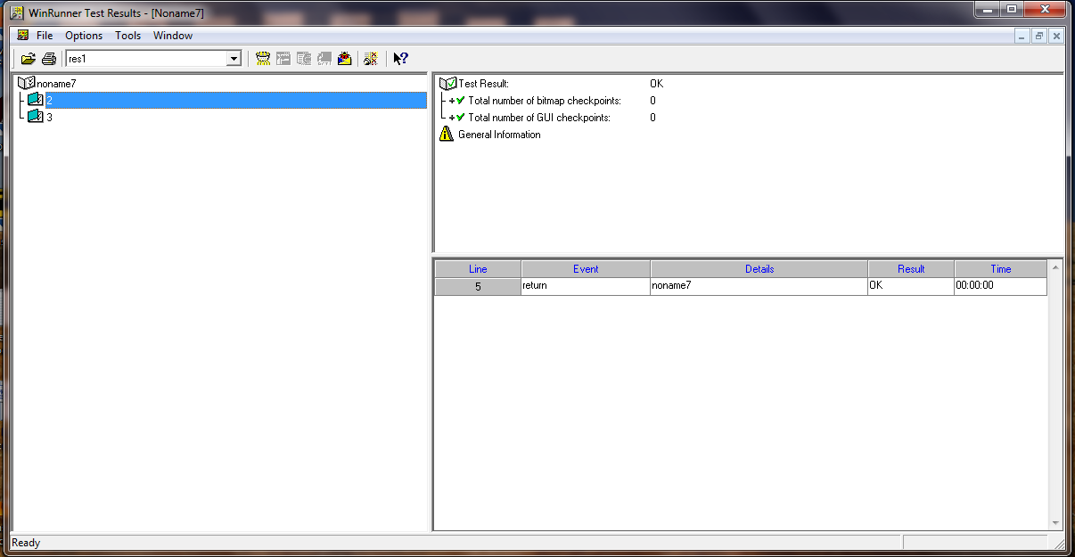

STEP-5: Test “3” results are shown here.

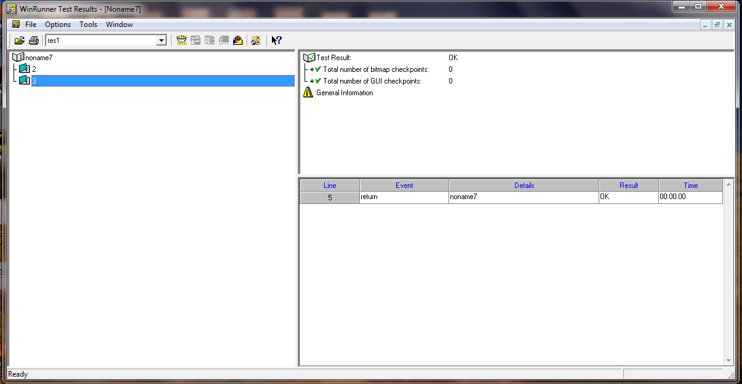

1. **Batch Test** **with parameter passing:** It is used to execute Multiple Tests in a single Batch Test.

**Syntax:**

Call “script1”();

STEP-1: Open WinRunner. A test is saved with the name “3” on Desktop. Insert its paths in the syntax.

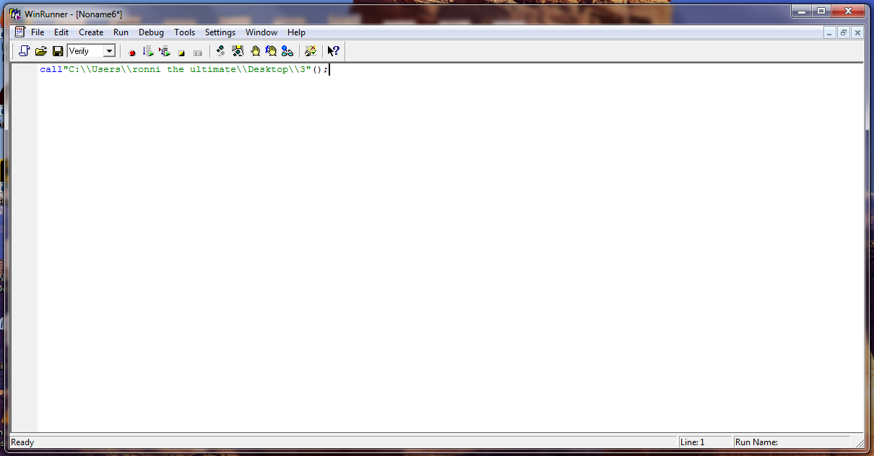

STEP-2: Goto Tool->Paramerize Data

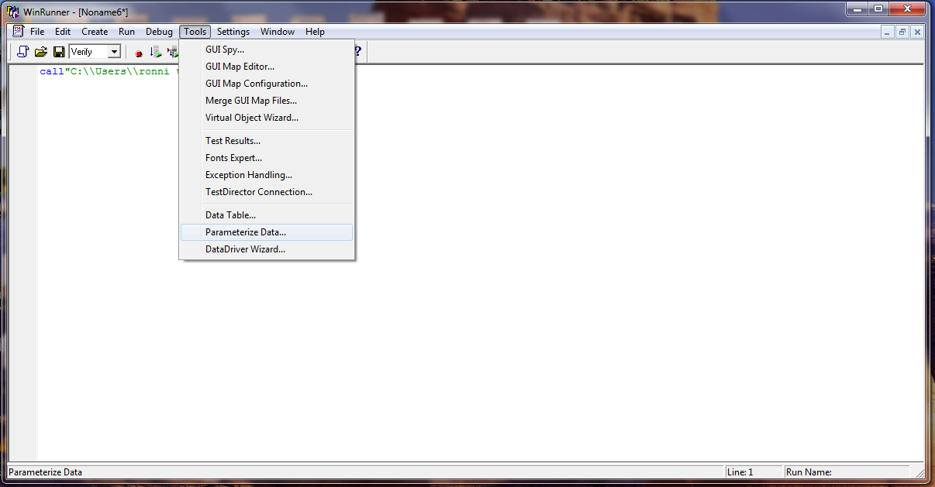

STEP-3: **Parameterize Data** window opens. Select **A new column**.

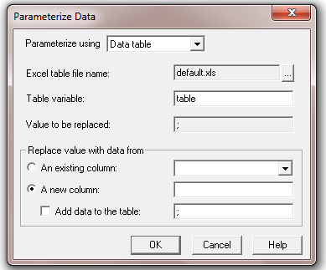

STEP-4: Type column name you want to. Select **Add data to the table** and type a value in the field.

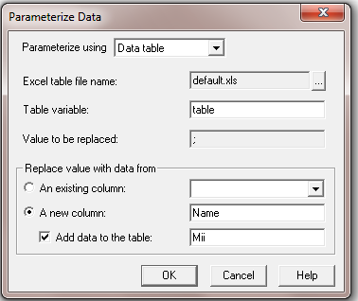

STEP-5: The function gets automatically written on the WinRunner screen.

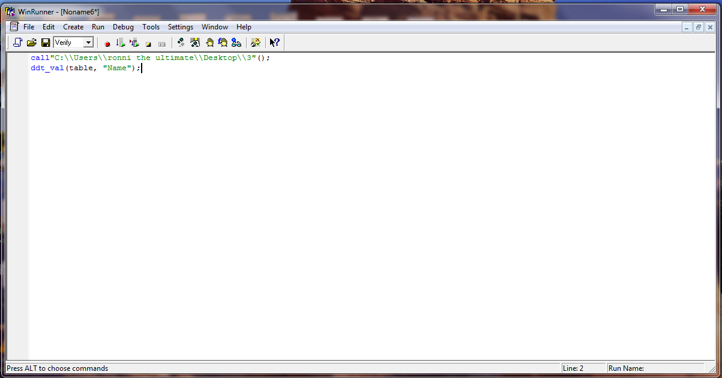

STEP-6: Goto Tools->Data Table

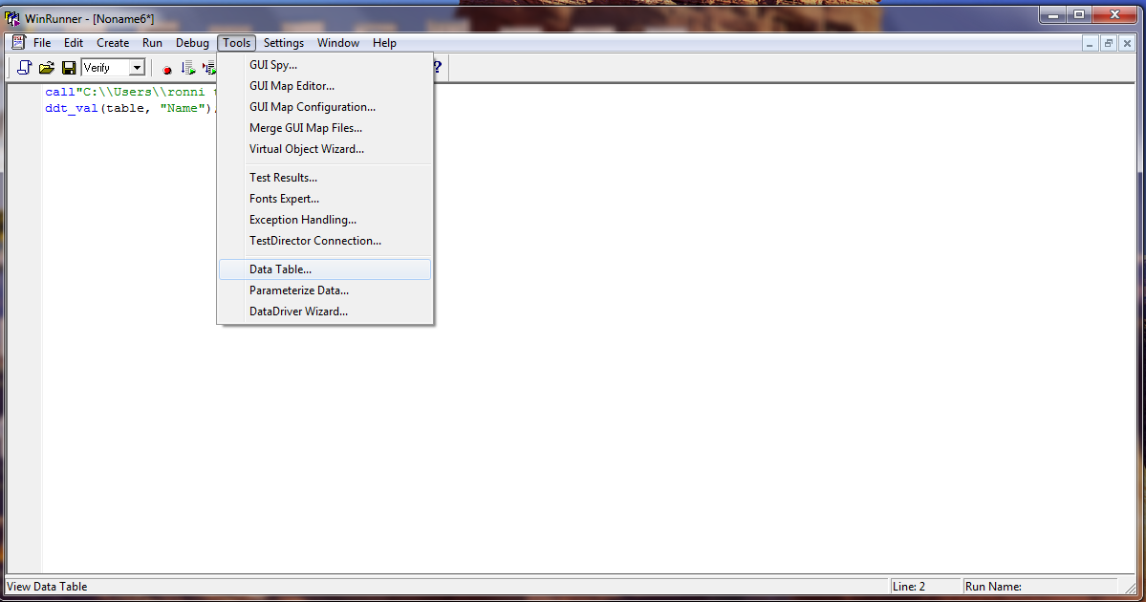

STEP-7: The column and data values you inserted will be stored in the Data Table and you can view them.

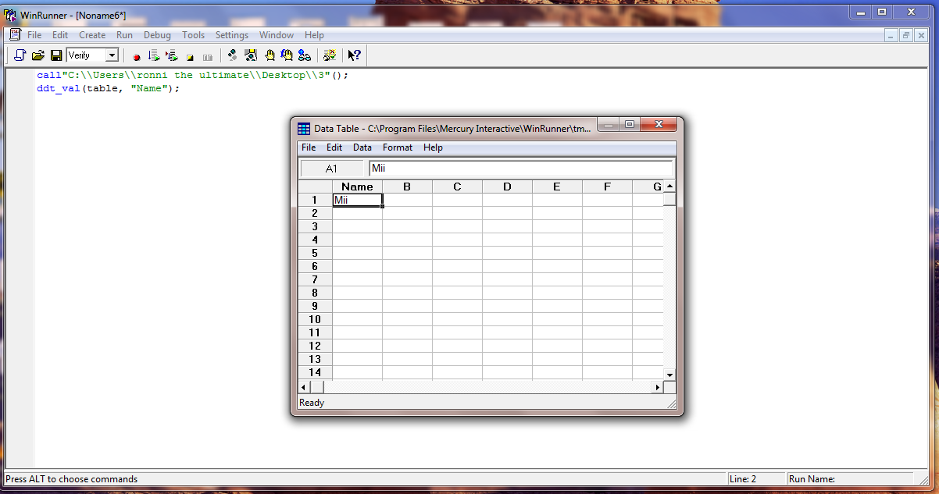

**TASK-7:** EXECUTING A PREPARED QUERY

**Executing a prepared query**: WinRunner allows us to execute a prepared statement. Prepared statement means a statement with variable and definition.

**Code**:

x= create_input_dialog ( “ enter order no : ”);

db_connect ( “query1”, “DSN=Flight 32” );

db_execute_query ( “query1 ”,”select * from orders”, x);

report_msg ( “The Number of Records Are : ” &x );

STEP-1: Write the code in WinRunner.

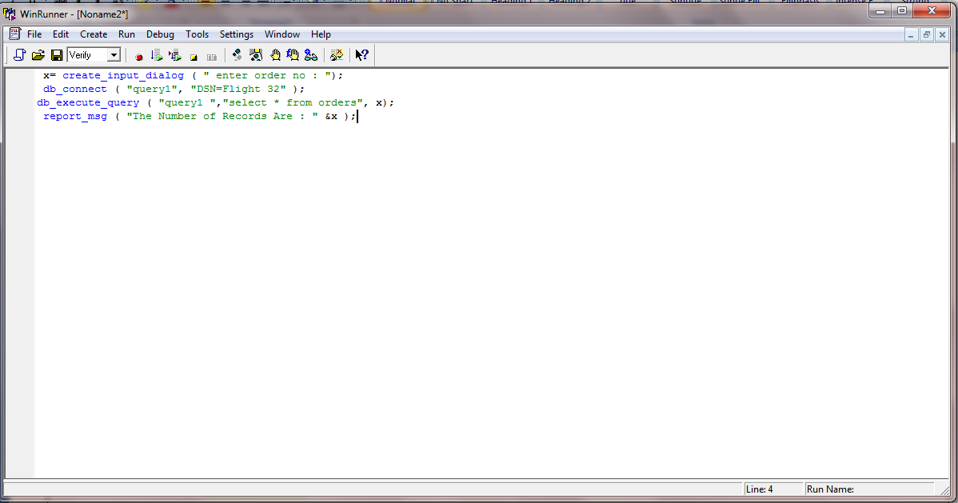

STEP-2: Run from Top.

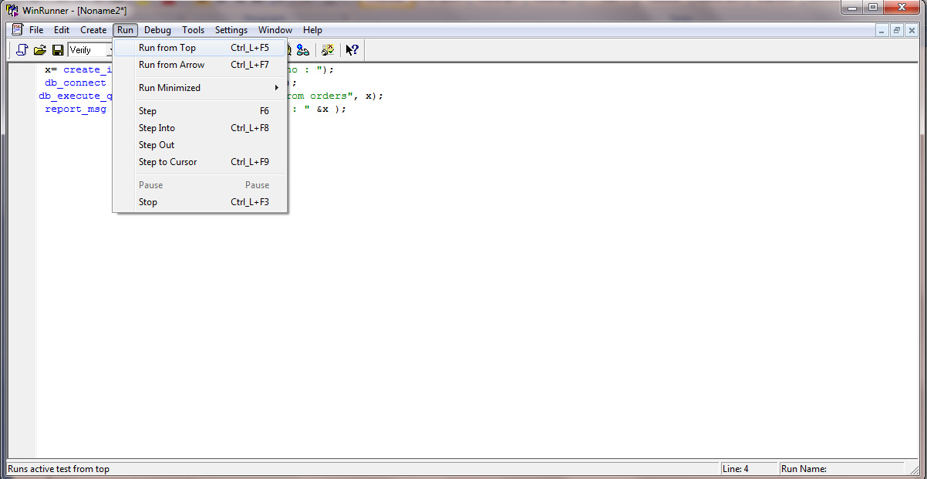

STEP-3: A window opens with a field “enter order no.”. Enter the order number and click OK.

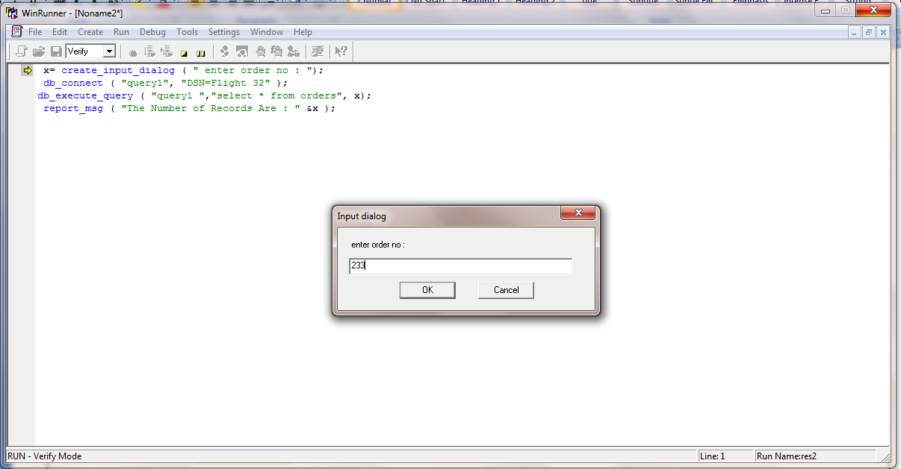

STEP-4: **WinRunner Test Results** window opens showing **The Number of Records** for the specified **order number**.

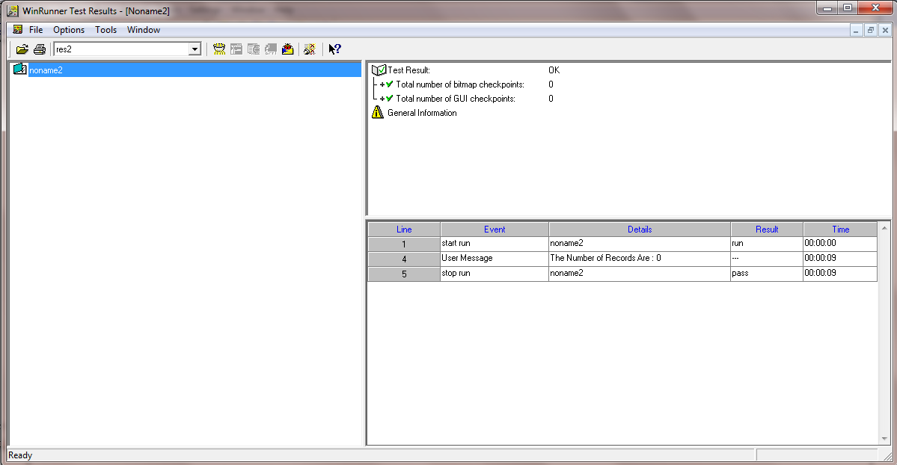

**TASK-8: FUNCTION GENERATOR**

**FUNCTION GENERATOR:**It is the library of TSL functions. Some testers use this option to detect unknown TSL Statements.

STEP-1: In WinRunner, Go to create -> Insert function -> From Function Generator.

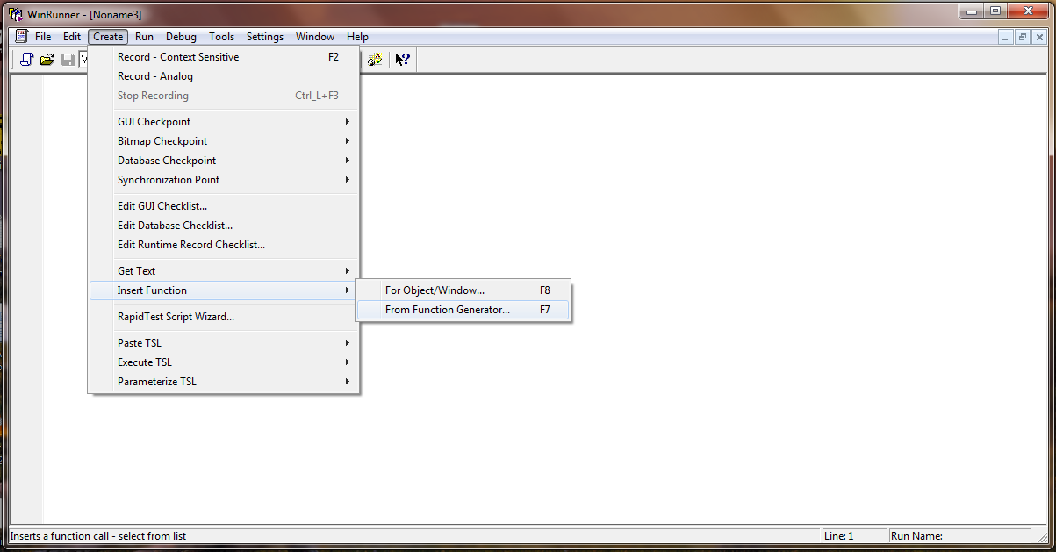

STEP-2: Select Category -> Select function name

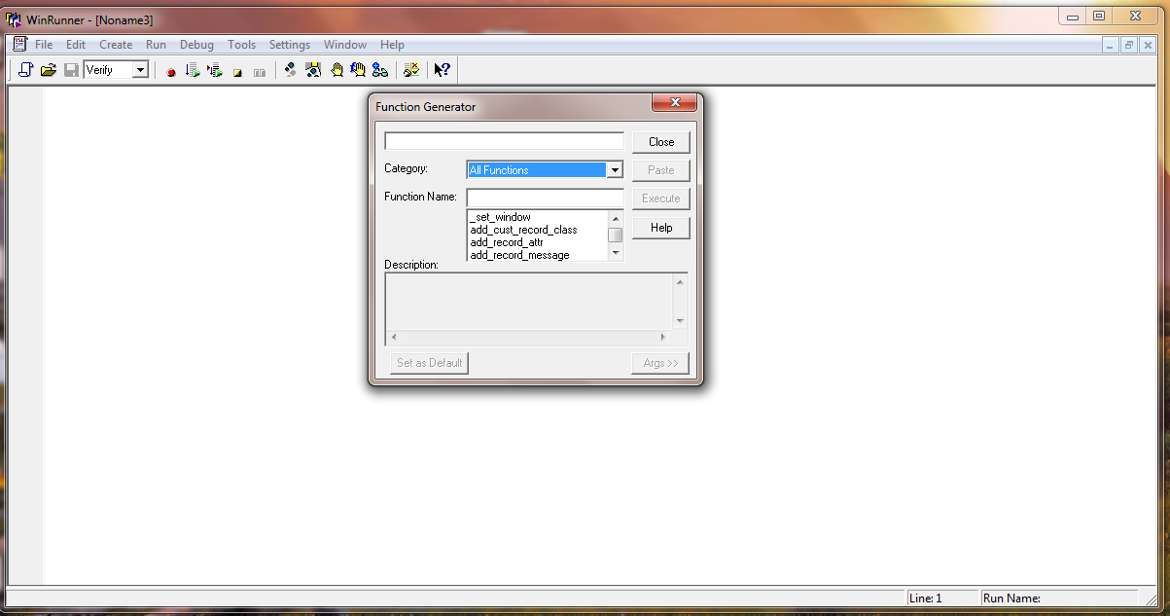

STEP-3: Select >>**Args**, type the arguments, click on **Paste**. The function will be pasted automatically on the WinRunner screen. In this manner the unknown TSL Functions can be generated through this navigation.

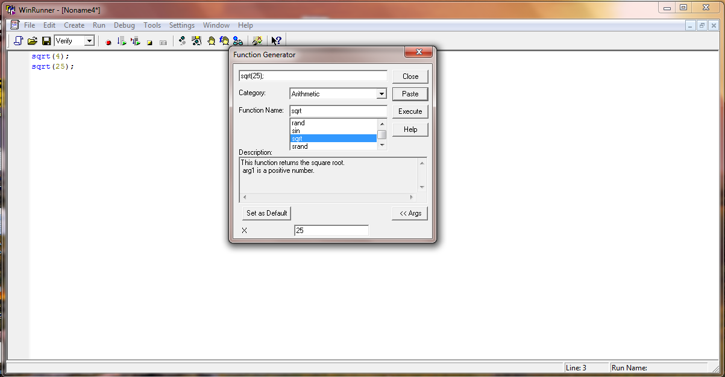

**TASK-9:**

1. SYNCHRONIZATION FOR OBJECT/WINDOW PROPERTY.
2. SYNCHRONIZATION FOR OBJECT/WINDOW BITMAP.
3. SYNCHRONIZATION POINT FOR SCREEN AREA BITMAP.

**Synchronization Point:** Synchronization points enable you to solve anticipated timing problems between the test and your application.

1. **For Object/Window Property:** Inserts a synchronization point into your test script. The synchronization point waits for a property of an object or a window to have an expected value.

STEP-1: Set Context sensitive mode.



STEP-2: Open Flight Application and Insert an order. Don’t close the Flight Reservation window.

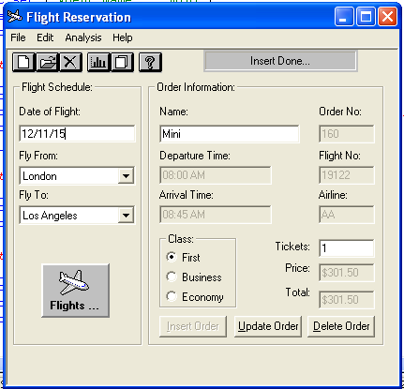

STEP-3: In WinRunner, goto **Create->Synchronization point->For Object/Window property**. Select any object/window in the Flight Reservation window and “Right click” on mouse.

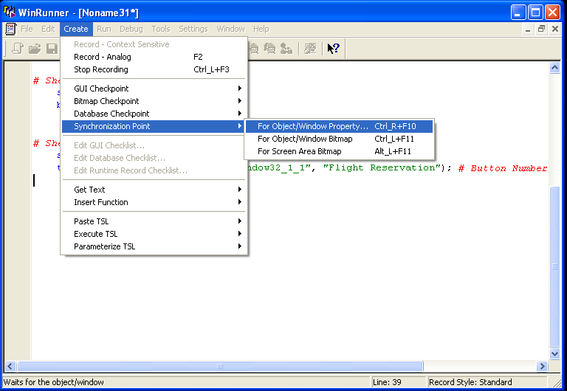

STEP-4: Click **Paste->**Close Flight 1A->Stop the procedure.

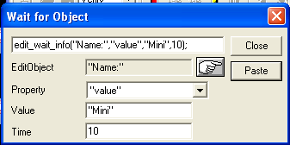

STEP-5: Run from Top and WinRunner Test Results window opens.

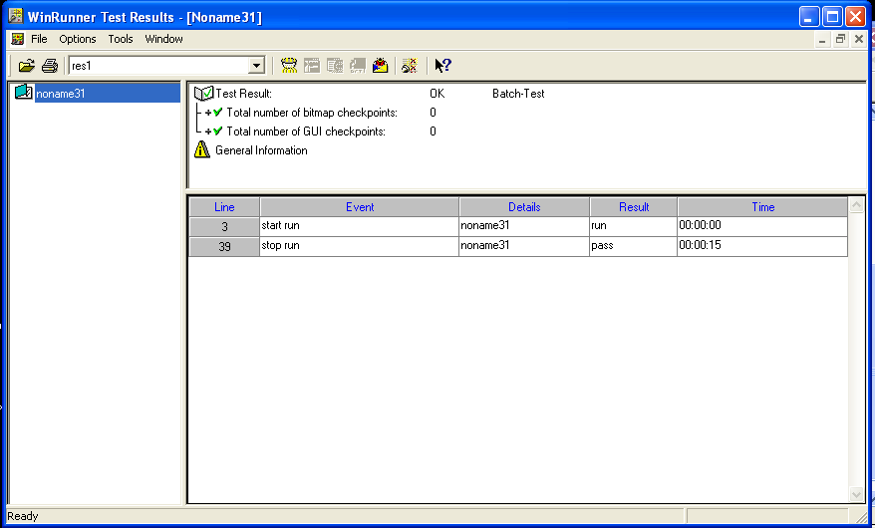

STEP-6: Change the time in the pasted TSL.

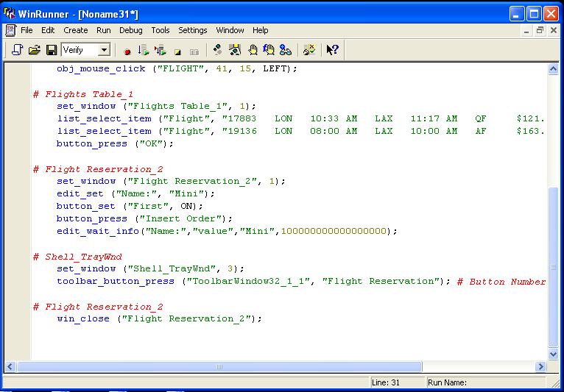

STEP-7: Run from Top->Time changes in results.

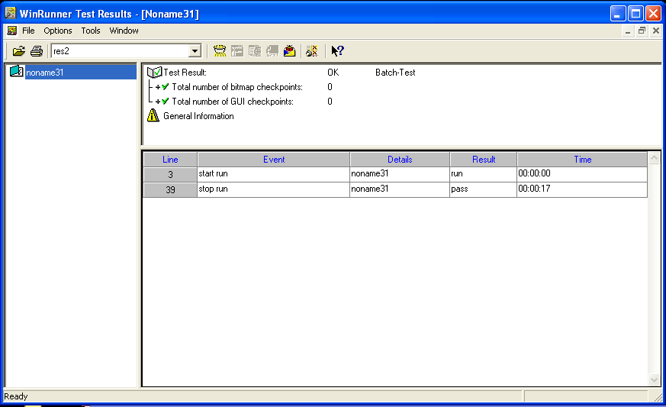

1. **For Object/Window Bitmap:** Inserts a synchronization point into your test script. The synchronization point waits for a specific bitmap to be redrawn. The bitmap is contained either in a window or in a GUI object.

STEP-1: Set Context sensitive mode.



STEP-2: Open a picture. Don’t close it.



STEP-3: In WinRunner, goto **Create->Synchronization point->For Object/Window Bitmap->Select the image->Close it->Stop Process**.

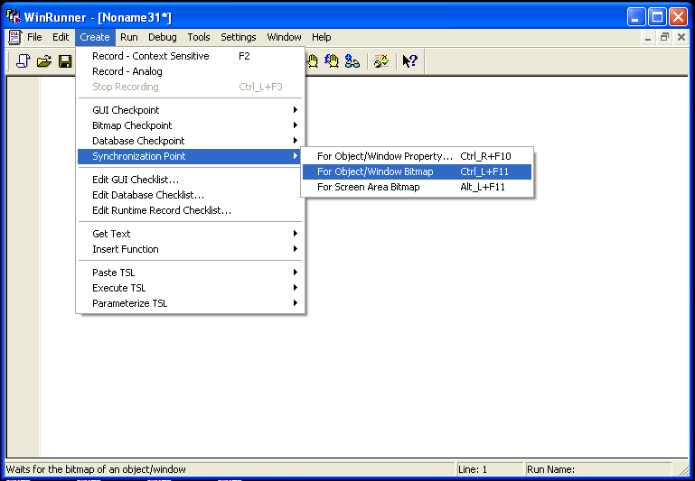

STEP-4: Run from Top and WinRunner Test Results window opens.

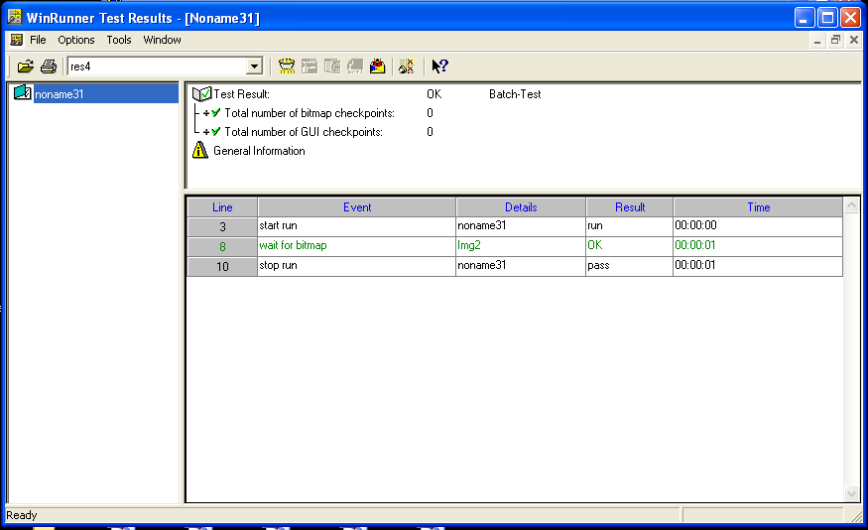

STEP-5: Change the time in the pasted TSL.

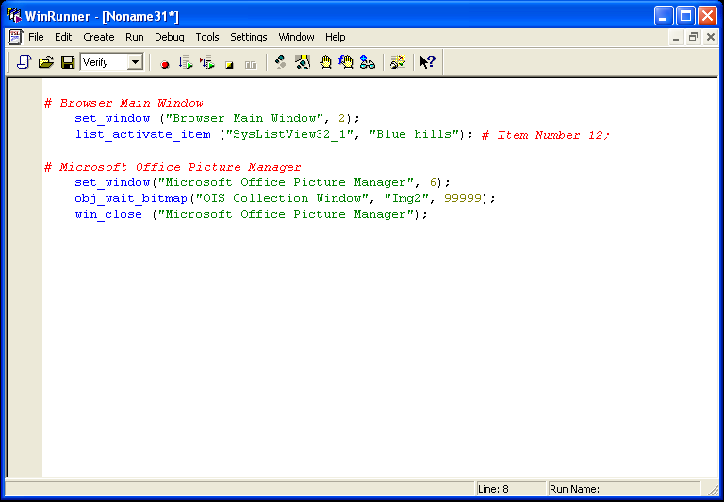

STEP-6: Run from Top->Time changes in results.

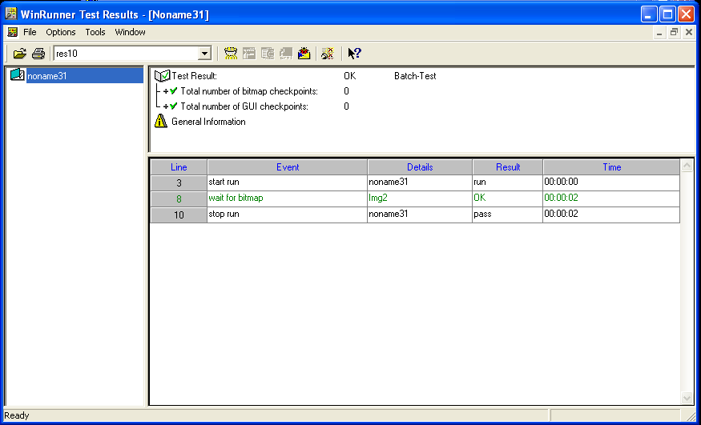

1. **For Screen Area Bitmap:** Inserts a synchronization point into your test script. The synchronization point waits for a specific bitmap to be redrawn. The bitmap is in a specific area of your screen.

STEP-1: Set Context sensitive mode.



STEP-2: In WinRunner, goto **Create->Synchronization point->For Screen Area bitmap.** Select a portion of screen area and **Right click** on mouse.

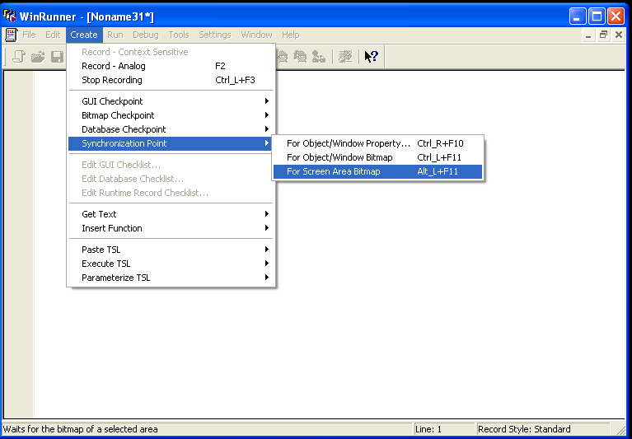

STEP-3: Run from Top. WinRunner Test Results window opens.

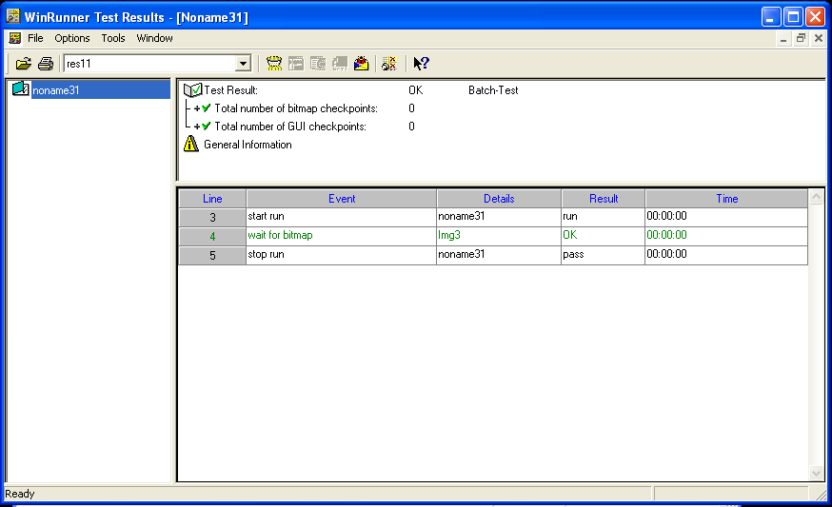

STEP-4: Change the time in the pasted TSL.

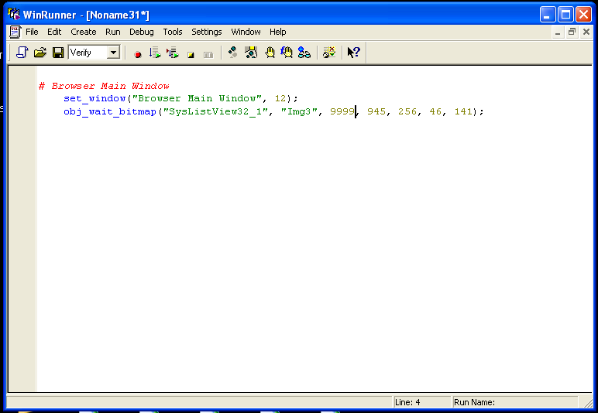

STEP-5: Run from Top->Time changes in results.

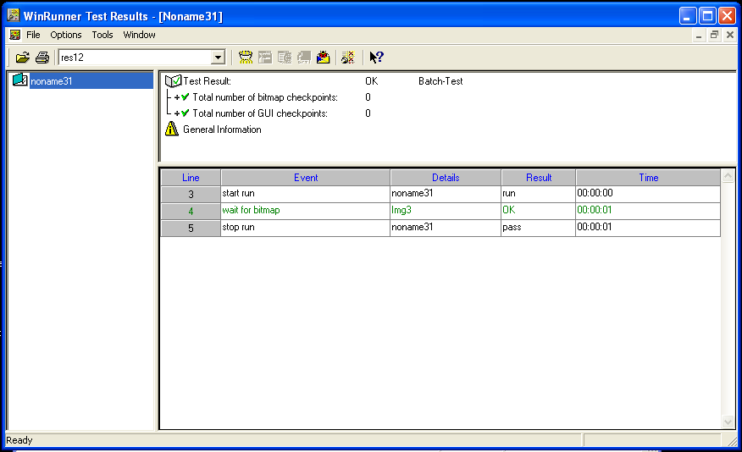

**TASK-10:** TEST CASES

1. **TEST CASES FOR CALCULATOR**

|  |  |  |
| --- | --- | --- |
| **Step Number** | **Input Requirement** | **Expected Output** |
| 1 | Click Calculator | Calculator screen appears |
| 2 | Check for following conditions addition, subtraction, multiplication, division | It works fine according to stated requirements |
| 3 | Check for following condition  Zero divide by some number | It displays ‘zero’ |
| 4 | Check for following condition  Some number divide by zero | It display ‘cannot divide by zero’ |
| 5 | Check for following condition  (-3*-3) | It displays -6 |
| 6 | Check for following condition  Number 99 subtracted by 3 | It displays minus ‘-‘ value |

**OUTPUT:**

Calculator screen appears

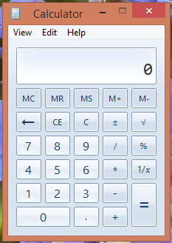

Checking conditions addition, subtraction, multiplication, division

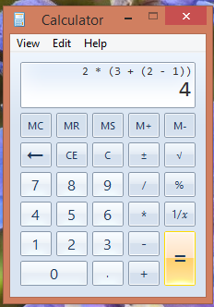

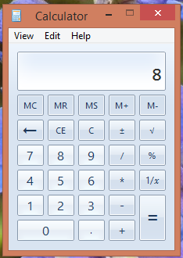

Check for condition -Zero divide by some number

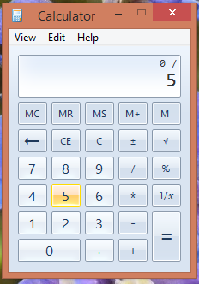

It displays ‘zero’

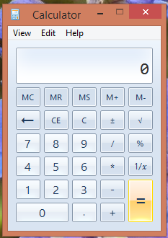

Check for condition -Some number divide by zero

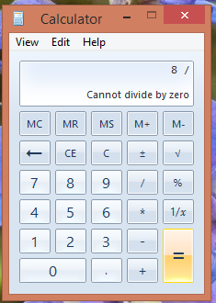

Check for condition -(-3*-3)

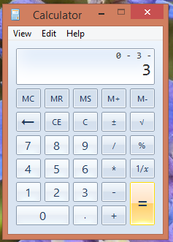

It displays -6

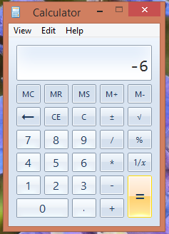

1. **TEST CASES FOR FLIGHT APPLICATION**

|  |  |  |  |
| --- | --- | --- | --- |
| **Step Number** | **Description** | **Input Requirements** | **Expected Output** |
| 1 | Launch the AUT |  | Login Screen appears |
| 2 | Enter Username and Password | Agent and mercury | Enter into Home page |
| 3 | Click the OK button | -------------------- | Main window display within 20 seconds |
| 4 | Close the AUT | --------------------- | Close page |
| 5 | Enter the following name, class and tickets | Customer, class and tickets | The price in the total textbox is number of tickets times the price in the price textbox |
| 6 | Click the insert order button | ---------------------- | Order Number textbox is populated |
| 7 | Close the AUT | ----------------------- | Close the Window |

**OUTPUT:**

STEP-1: Start->Programs->WinRunner->Create->Record-Context Sensitive



STEP-2:Open Flight Reservation application, a **Login** window opens.



STEP-3: Fill in your desired **Agent Name** and “mercury” as **Password.**



STEP-4:Fill in the details for flight reservation and press “Insert Order”.

STEP-5:Run from Top 

STEP-6: View the test results in the **WinRunner Test Results** window.

